Juniper Networks – A Sample Strategic Planning Analysis

Table of Contents
Introduction | 4
Current Vision Statement | 4
Proposed Vision Statement | 4
Current Mission Statement | 4
Proposed Mission Statement | 5
Current Status of Industries | 5
Overview of the Firm | 8
Competitive Profile Matrix (CPM) | 9
Financial Statements and Historical Ratios | 10
Internal and External Factor Evaluations | 14
Proposed Strategies Developed from SWOT Matrix | 18
Strategic Position and Action Evaluation (SPACE) | 19
Boston Consulting Group Matrix (BCG) | 21
Internal-External Matrix | 22
Grand Strategy Matrix | 24
Quantitative Strategic Planning Matrix | 25
Recommendations | 28
Explanations for Recommendations | 29
Organizational Chart | 31
Proposed Organizational Chart | 32
Perceptual Map | 33
Firm Valuation | 34
EPS-EBIT Analysis | 35
Projected Financial Statements | 39
Projected Financial Ratios | 41
Retained Earnings Table | 42
Epilogue | 42

Introduction

Founded in 1996, Juniper Networks designs, develops, and sells products and services for high-performance networks to enable customers to build scalable, reliable, secure and cost-effective networks for their businesses while achieving agility and improved operating efficiency through automation. Juniper Networks is headquartered in Sunnyvale, California and incorporated in Delaware. Company common stock is traded on the New York Stock Exchange under the abbreviation JNPR. Juniper Networks currently employs over 10,000 employees in 109 offices across 47 countries. Annual revenue as of 2019 was $4.45 billion.

Current Vision Statement

We exist to solve the world’s most difficult problems in networking technology. We bring simplicity to networking with products, solutions, and services that connect the world.

Proposed Vision Statement

We exist to make the technology needed to power communications simply through innovative engineering, meeting the needs of today and the future.

Current Mission Statement

A company of innovators, we believe that creating simplicity through engineering is the highest form of innovation. From our first release, the ground-breaking M40 router, to today’s end-to-end advancements in network security, automation, performance, and scale, our drive to move beyond the constraints of complexity has expanded the reach of networks everywhere. We’ve enabled our customers to connect to everything and empower everyone in ways that have literally changed the world.
In the profusion of new technologies such as IoT, big data, and multi-cloud, complexity is the new hard problem. And complexity is on the wrong side of progress.
With the strength of our resolve, we’ll champion the evolution of the cloud and once again change the world.
Simple is our obsession.
Simple is powerful.
And simple always starts with engineering.

Proposed Mission Statement

Our employees continue to build on a legacy of innovation (9) centered on meeting the ever-changing needs of our customers (1). We seek to provide the flexible, automated, and secure solutions (2) necessary to connect devices of all types to one another (4) with simplicity through innovative engineering (7). We have been the first to deliver needed products and advancements since our founding, and we will continue to ethically deliver products (6) for the future that ensure our continued work (5) of enabling our customers to connect to everything and empower everyone (3) in ways that will continue to literally change the world. (8) [94 words]

(1) Customers
(2) Products or services
(3) Markets
(4) Technology
(5) Survival, growth and profitability
(6) Philosophy
(7) Distinctive competence
(8) Public Image
(9) Employees

Current Status of Industries

Juniper Networks is primarily involved in the Telecommunication Networking Equipment Industry. This industry manufactures wired (voice and data) telecommunications equipment, including telephone switching systems, telephones and answering machines, data bridges, routers, modems and gateways. In addition, over the past 10 years, the industry has increasingly focused on manufacturing internet protocol-based telecommunications and networking equipment. (IBISWorld report 33421). The forecast for this U.S. industry is future decline as other countries continue to build capacity to deliver the same products at a lower price.

The Telecommunication Networking Equipment Industry is found in the “Decline” section of the Indicative Industry Life Cycle indicating shrinking economic importance:

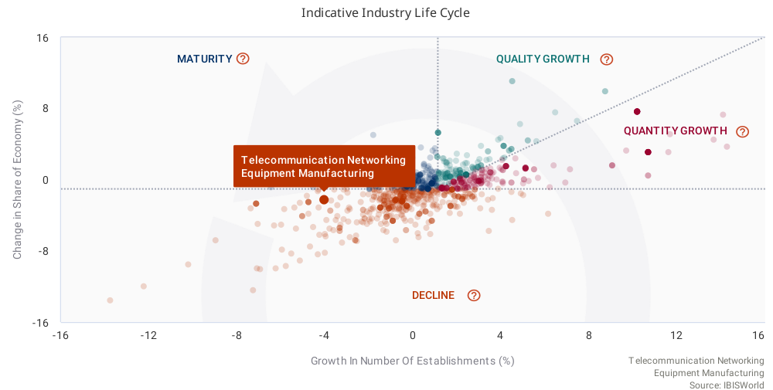

Juniper Networks is also involved in the Software Publishing industry, primarily through their creation, distribution, and service of the Junos Operating System which powers their hardware offerings. Software publishers disseminate licenses to customers for the right to execute software on their own computers. Operators in this industry market and distribute software products and may also design the software, produce support materials and provide support services. Rising private investment in computers and software stimulated demand from businesses, while rising disposable income levels encouraged consumers to spend on software as well. Moreover, new internet-based solutions and the increasing popularity of mobile devices have triggered an explosion of mobile software applications. From 2020 to 2025, industry revenue is estimated to rise at an annualized rate of 6.4% to $293.1 billion. In 2020, the industry is anticipated to endure subdued revenue growth of only 1.9%, as the COVID-19 (coronavirus) outbreak reduces consumer spending and private investment levels.

Software publishers are often highly profitable despite the prevalence of software piracy, ongoing litigation and an expensive workforce. Over the past five years, publishers have focused on strategic acquisitions and product development, with large software publishers regularly acquiring smaller operators with specialties in high-growth, niche markets. Additionally, most operators have switched to the software-as-a-service (SaaS) model to stabilize cash flows. This model makes it more affordable to buy software products, enticing smaller and cash-strapped companies to make purchases while also facilitating easy scalability and frequent software updates.

Projections of the industry from 2020 to 2025 suggest the growing ubiquity of software in daily activities and the rise of predictive analytics and artificial intelligence software will benefit the industry by expanding software publishers' product offerings and potential markets. For example, connected cars, smart appliances and automated logistics services are all expected to continue integrating with the daily activities of US consumers and businesses. Mobile computing devices are also providing new platforms on which operators can compete, while cloud computing is opening a wider array of software possibilities for mobile phones and tablets that are no longer hampered by low storage capacities. Additionally, demand for security software to protect data is expected to rise, especially after high-profile cybercrimes gripped the nation in recent years. Altogether, revenue is expected to rise at an annualized rate of 2.4% to $329.9 billion over the five years to 2025.

The Software Publishing Industry is firmly in the “Quantity Growth” quadrant of the Indicative Industry Life Cycle indicating smaller growth of economic importance spread across many new companies:
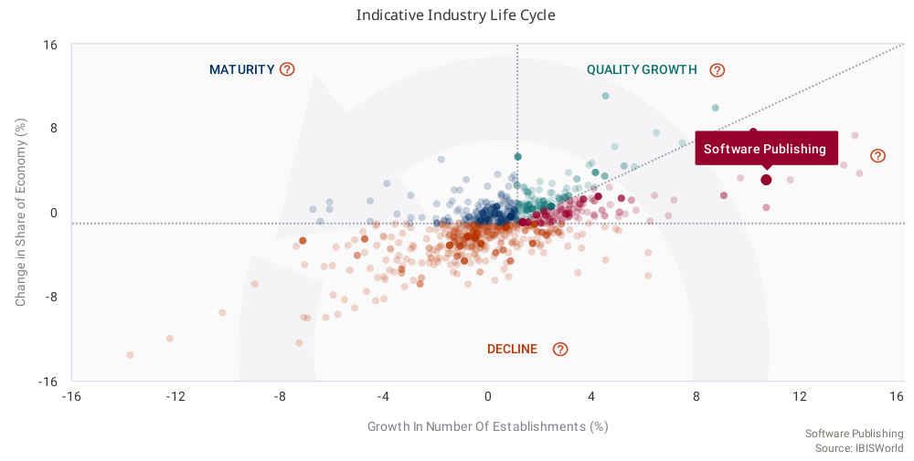

Overview of the Firm

Juniper Networks is at a pivotal point in its history. Many investments that have been years in the making are ready to begin seeing returns such as completing a stock buyback program, paying down debt, all while expanding its portfolio of offerings. However, key metrics such as Net Revenue and Net Income have continued to decline, and Juniper Networks faces competitors with significantly more resources in a difficult and competitive environment. The following pages will detail the position of Juniper Networks and formulate strategies for the future.

Competitive Profile Matrix (CPM)

Below is a Competitive Profile Matrix for Juniper Networks comparing the firm to two of its primary rival firms: Arista Networks and Cisco.

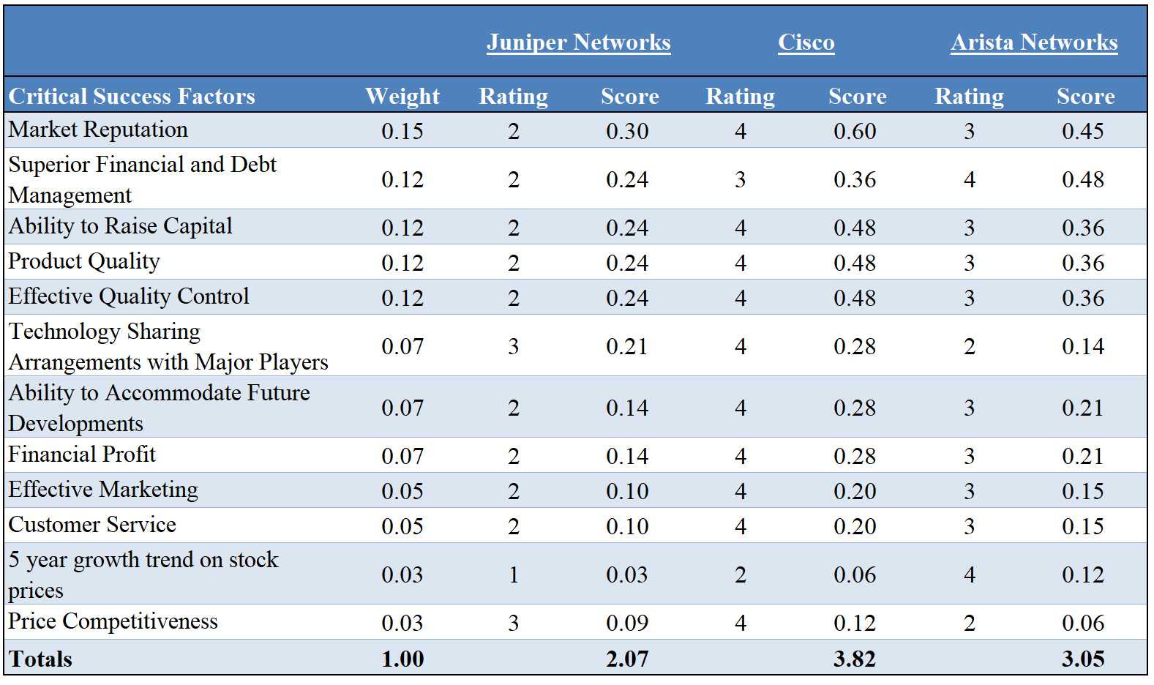

Juniper Networks is not performing poorly in the market overall, but it’s composite 2.07 CPM Matrix compared to Cisco’s 3.82 and Arista Networks’ 3.05 indicates that its rivals are performing better on the variables critical to the telecommunication manufacturing industry. Finding a distinct, competitive advantage that separates it from the companies in the upper echelon of the industry has thus far alluded the firm. With its two primary competitors consistently delivering on critical success factors more successfully, Juniper Networks must evaluate its strategic plan to adjust its current trajectory.

Financial Statements and Historical Ratios

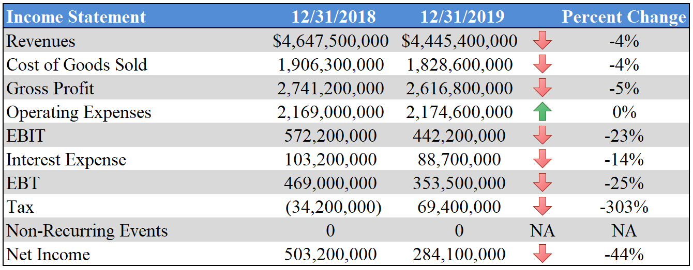

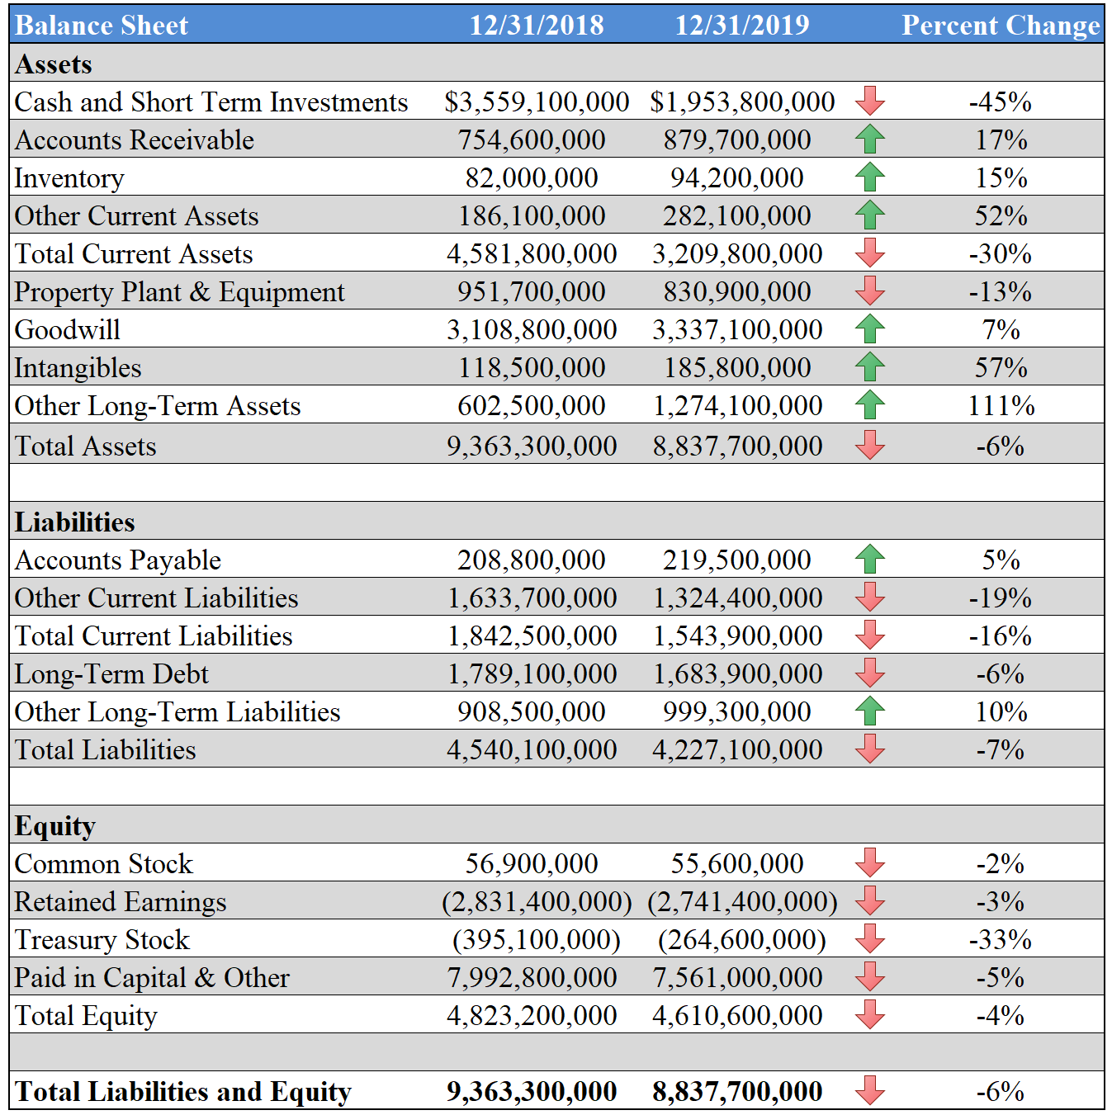

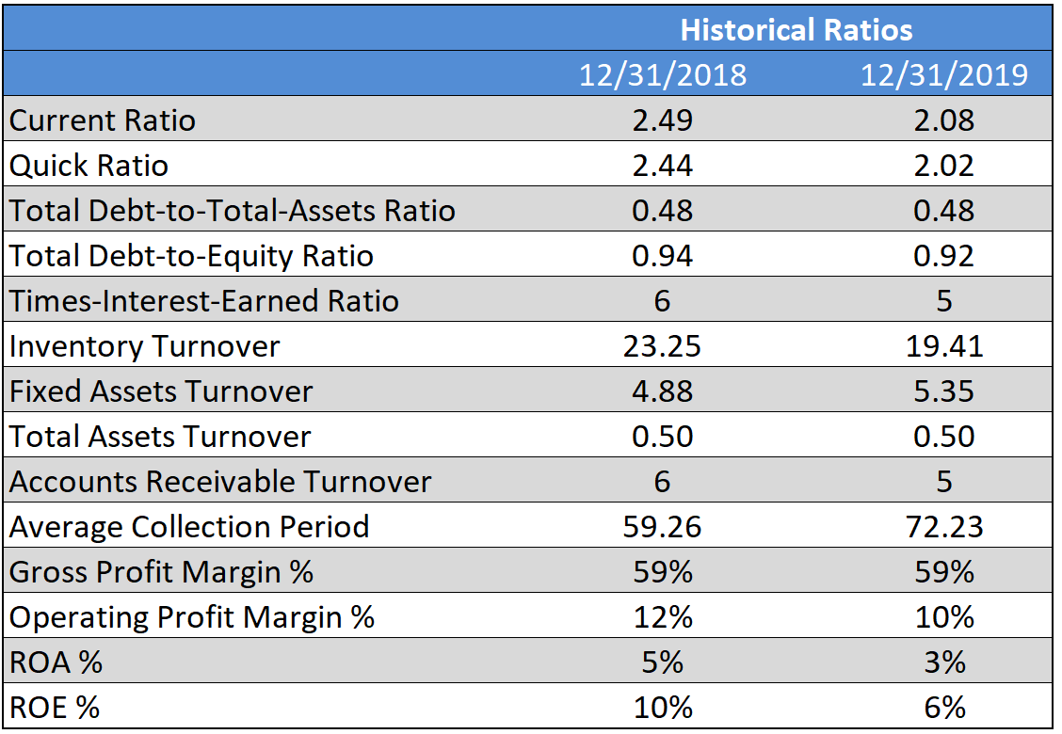

What quickly stands out from an analysis of the financial statements is the downturn in revenue and net income. The firm has made recent strategic decisions to expand its product portfolio, reduce debt, and increase its dividend payout in the past three years. This is an ambitious set of goals, but those investments have yet to yield the necessary results to Total Revenue and Net Income. The primary issue facing the firm at this time is a trend of shrinking revenue in its largest division: Product. Juniper Networks needs these recently acquired assets to quickly begin yielding appropriate returns.

On the positive side, the firm enjoys above average standings on debt ratios related to the industry, as well as an operating margin three times above the industry average. They facilitate this by primarily outsourcing the manufacturing of the equipment, allowing them to hold down costs. This strategy is not without its drawbacks, as those manufacturers may shift to other vendors with no long term contracts and are subject to supply chain issues that Juniper can do little to resolve. Tariffs and other foreign policy decisions made by the leaders of the countries in which these manufacturers exist can also cause the price per unit to increase, leading to ambiguity in the margins and harming financial planning.
The next three years will be critical for Juniper Networks. The strategy of deep investment in the product portfolio along with a reputation as a shareholder centric firm necessitate the market respond to their offerings quickly if they are to be successful. Finding capital from other sources is possible, but less desirable as the risk of this firm is currently higher than its primary competitors due to the revenue trends and equity positions of the firms.

Internal Factor Evaluation (IFE) and External Factor Evaluation (EFE) Matrices

The Internal Factor Evaluation (IFE) Strengths for Juniper Networks are as follows:

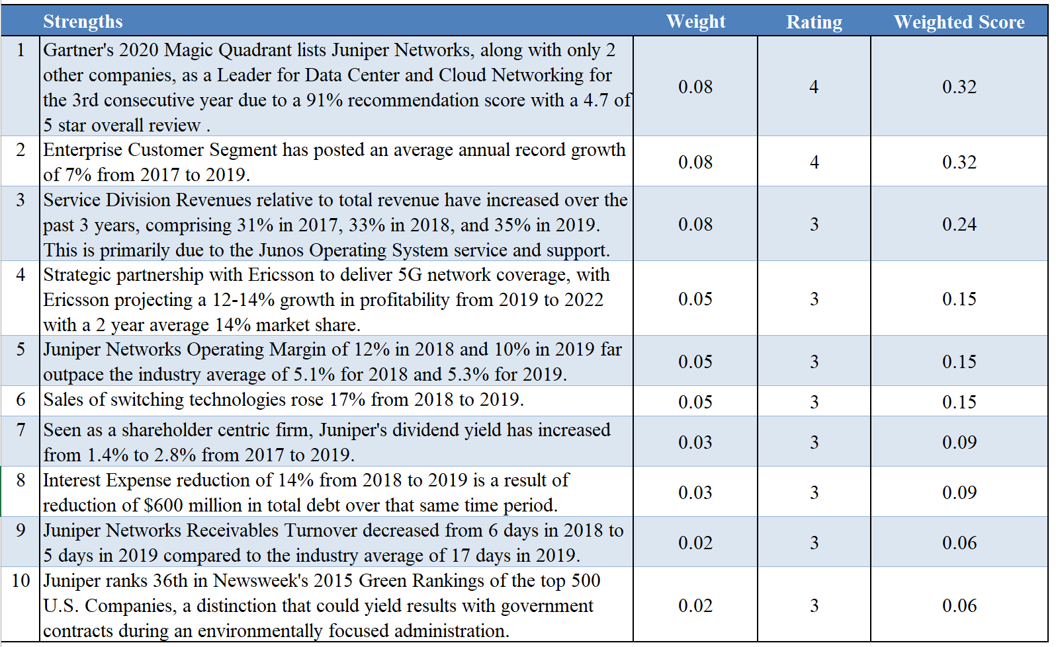

The Internal Factor Evaluation (IFE) Weaknesses for Juniper Networks are as follows:
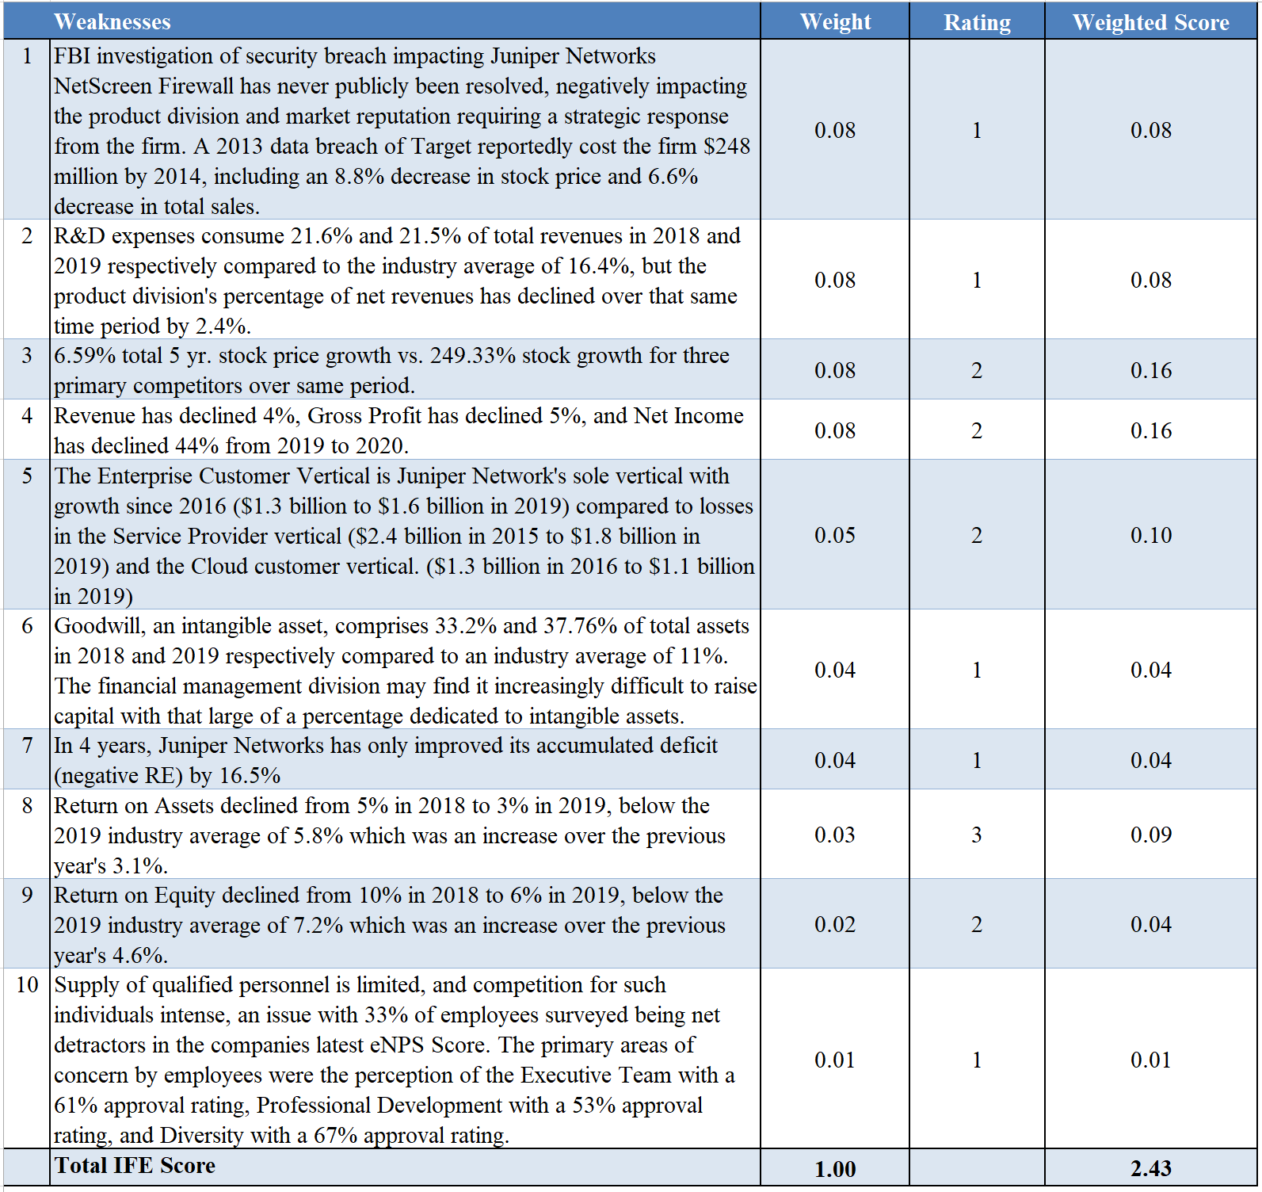

The External Factor Evaluation (EFE) Opportunities for Juniper Networks are as follows:

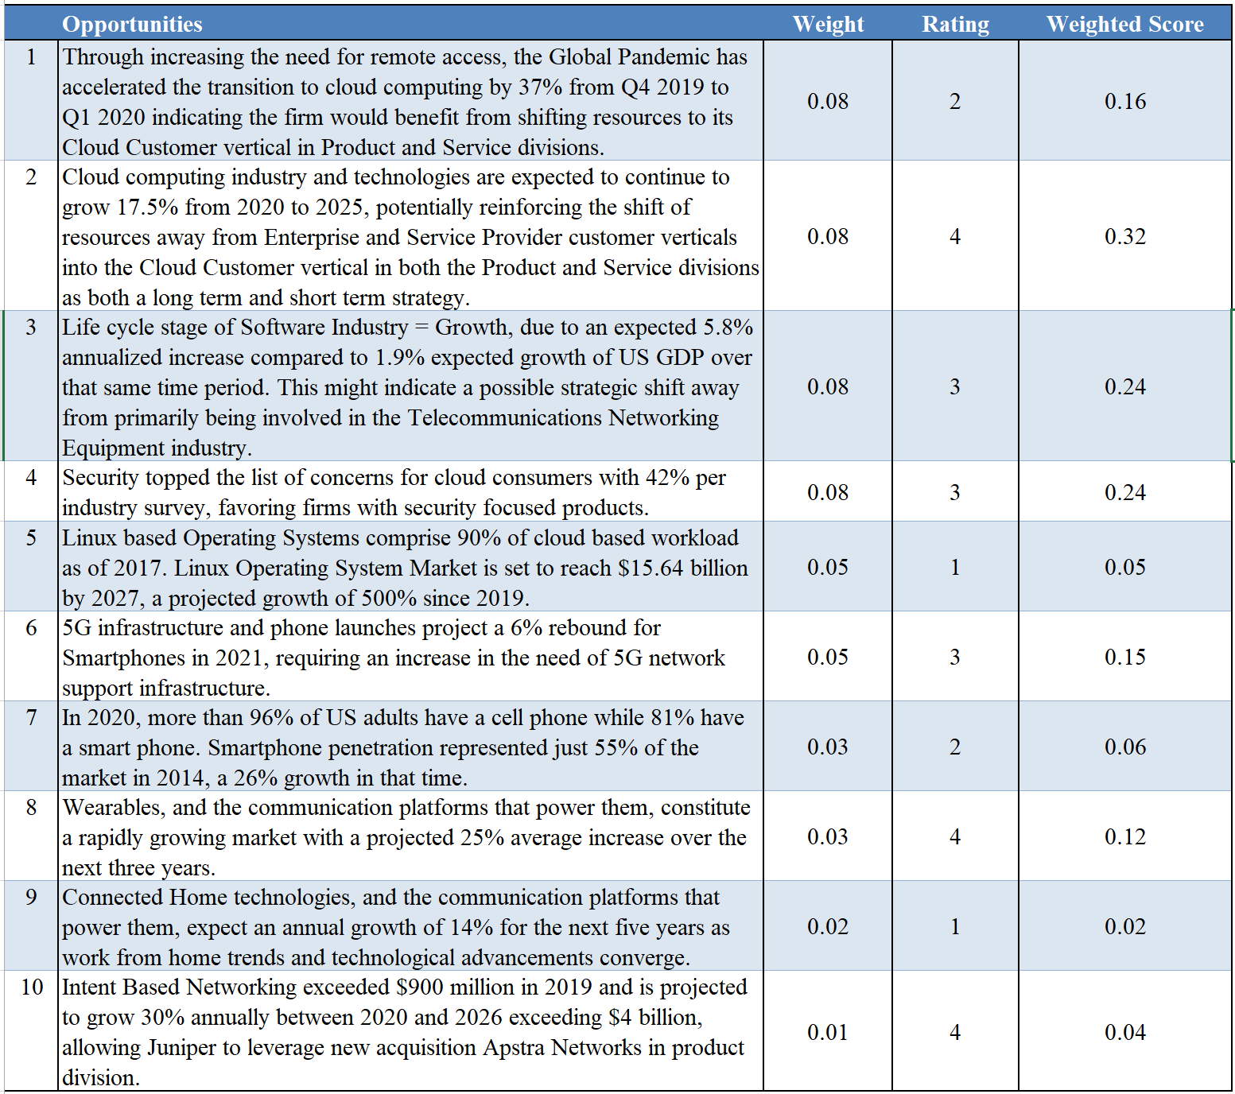

The External Factor Evaluation (EFE) Threats for Juniper Networks are as follows:

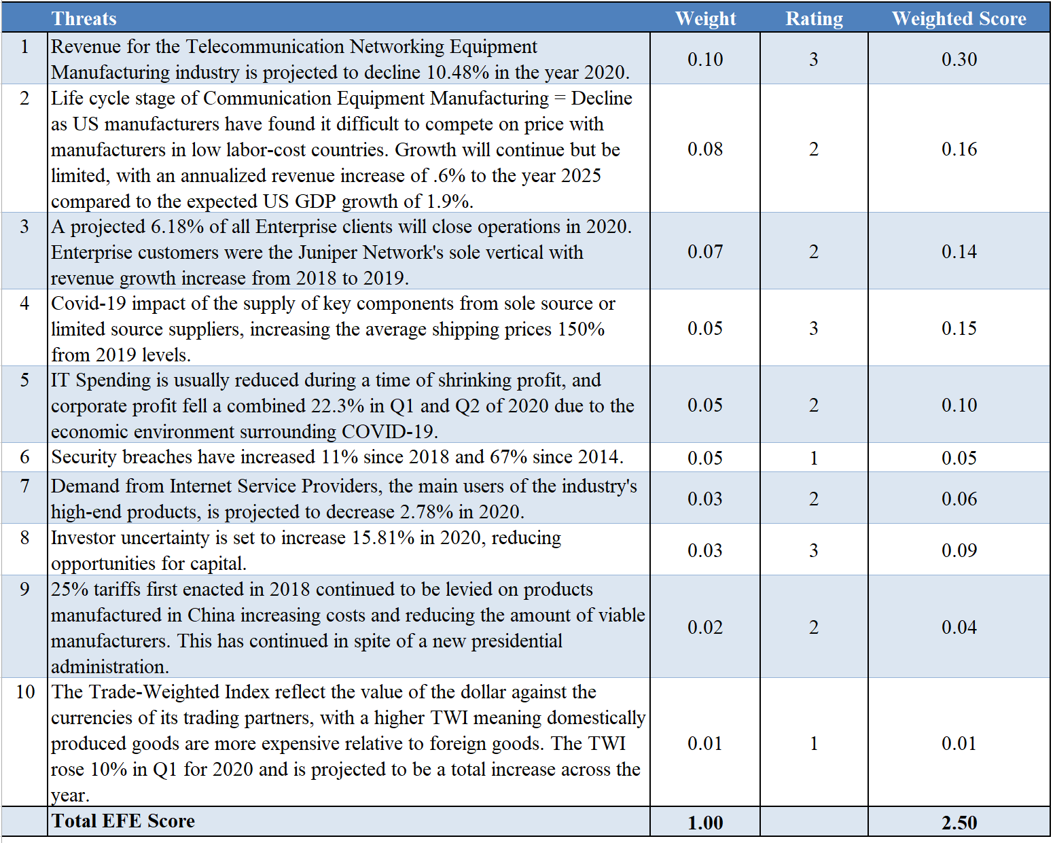

Some key points to note: A key weakness of Juniper Networks relates to a 2015 FBI investigation around an international and embarrassing security breach that was never publicly resolved. This weakness is directly related to a key opportunity of consumer expectations of privacy and security combined with a key threat of the increasing annual corporate security breaches.

Long term, the U.S. Telecommunications industry is in decline and Juniper Networks does not have the resources to continue to attempt to do so many things for so many types of customers. A distinctive competence must be identified, pursued, and achieved. The Software Publishing Industry is growing and represents a set of intriguing opportunities that will be discussed in the strategic plans listed below.

Proposed Strategies Developed From SWOT Matrix

Strength-Opportunity (SO) Strategies

Weakness-Opportunity (WO) Strategies

Strength-Threat (ST) Strategies

Weakness-Threat (WT) Strategies

The best strategies for continued growth of Juniper Networks will be discussed in the Recommendations section below. But one strategy listed above should occur regardless of any other decision that will be made. That strategy is the Weakness-Opportunity Strategy of achieving a 3rd party certification for outstanding security practices and auditing. With security breaches increasing every year and security being the top concern of consumers per industry surveys, Juniper Networks must publicly address the 2015 security breach and subsequent FBI investigation. This certification would position them to positively communicate their proficiencies in this area, with validation from an external, unbiased party. This will address a key weakness, capitalize on an emerging opportunity, and ensure a growing threat is mitigated.

Strategic Position and Action Evaluation (SPACE) Matrix

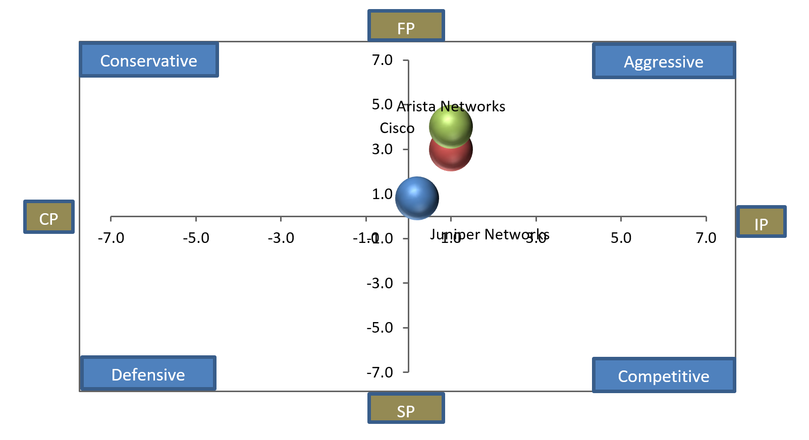

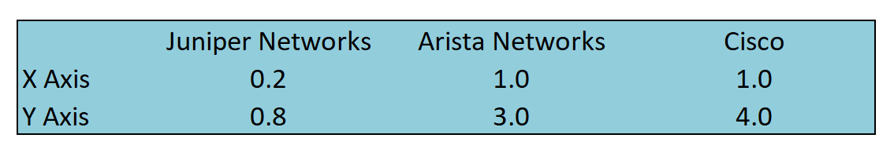
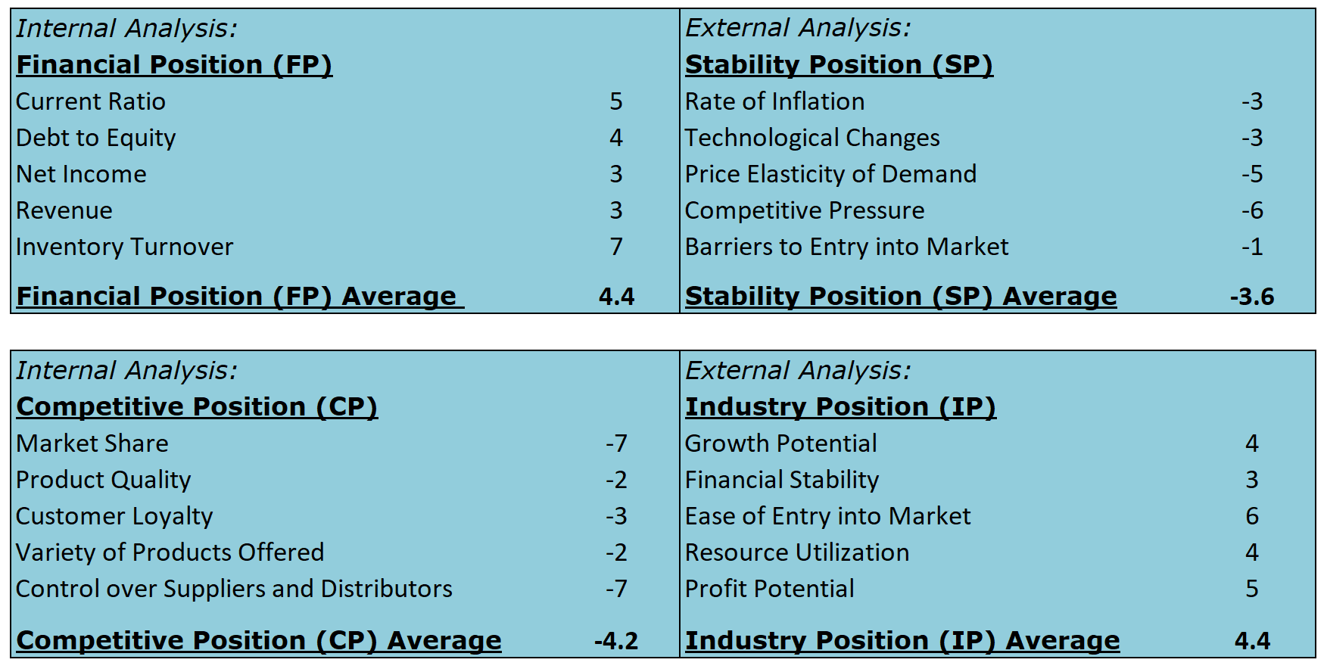
The SPACE Matrix further illustrates Juniper Network’s need to solidify a sound strategy moving forward. Juniper Networks does have the resources to use its internal strengths to take advantage of external opportunities, overcome internal weaknesses, and avoid external threats. However, Juniper Networks is also very close to the very center of the matrix, indicating that near future events could quickly remove that flexibility and force them into more undesirable choices. That could quickly cause Juniper shift strategies out of necessity rather than careful and measured planning.

BCG Matrix

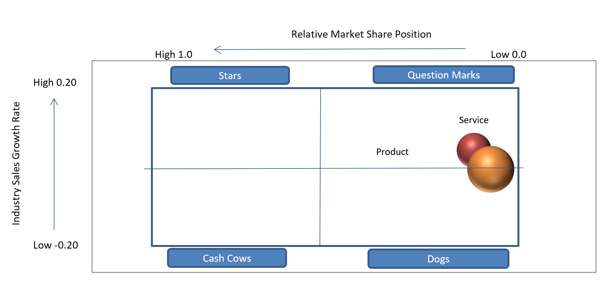
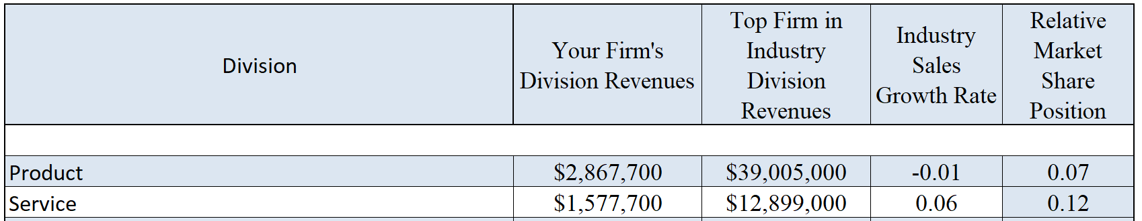

The BCG Matrix continues the theme of an inflection point for Juniper Networks. The Product division is just below the industry average in sales growth rate, and is toward the bottom of market share. Coupled with an overall declining industry, this is a concerning position.

Both the Product and Service Divisions need to focus on increasing Market Share, but Juniper Networks may lack the resources to do that in both divisions without significant costs due to restructuring or debt. Market share increase will only be seen by achieving a competitive advantage above other firms in the space. The trajectory of the Software Publishing Industry likely makes the Service Division the better choice for future development.
Internal-External (IE) Matrix

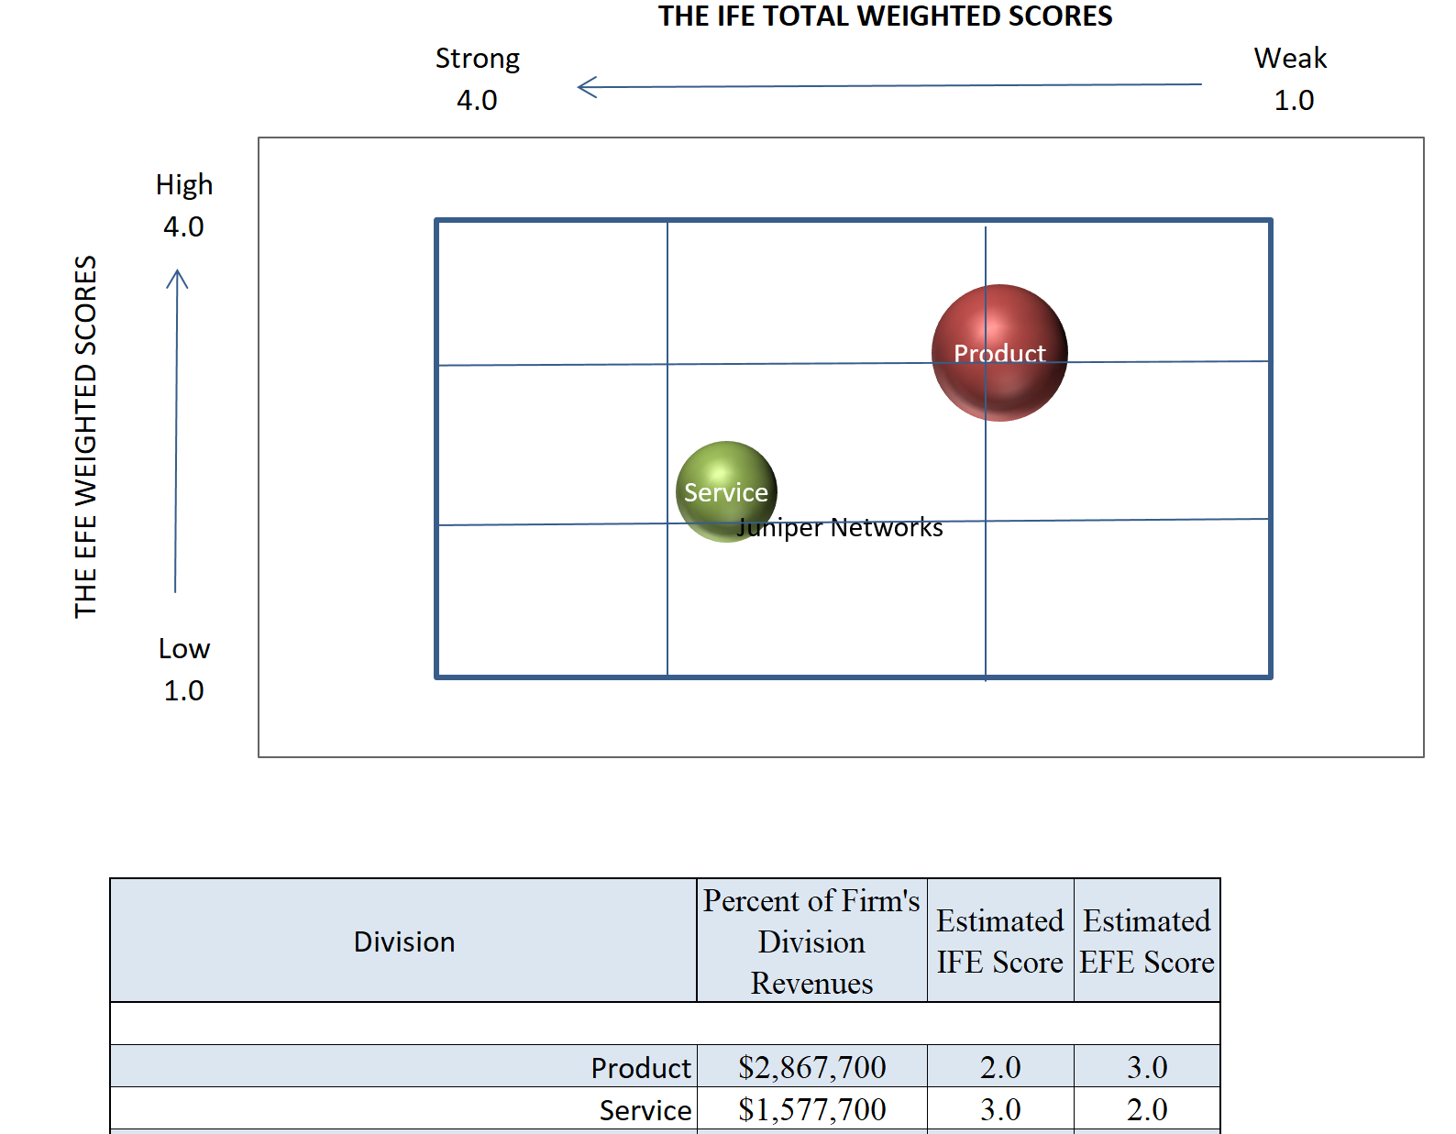

Juniper Networks’ two divisions are primarily positioned to suggest the firm’s focus should be on Market Penetration and Product Development. But the placement of these divisions are very close to requiring an alternative strategy, and these underlying stories will be discussed in the following paragraphs.

Product: The placement of this division illustrates the difficult choices facing Juniper Networks in the near future. Current positioning suggests that Juniper Networks must choose between one of two paths. The first would primarily be concerned with increasing market share via market penetration and developing the product to either dominate in cost or differentiation. In considering the results of the SWOT analysis and industry trends, Juniper Networks would be best serviced to focus on product differentiation of connecting all devices through a centralized solution if this strategy is chosen.
The second strategy would suggest the firm refocus this division’s core business and become less diversified. This would cause Juniper Networks to divest from less profitable portions of the product division, such as routing, and focus on the growing industry trend of cloud computing.

Service: The placement of this division illustrates its relative strength in the market. With the proper internal focus, this could be shifted into an intensive growth strategy including a focus on market penetration, market development, or product development. Doing this would mean that even if external forces outside of the firm’s control were to impact the division it would still remain in a favorable position with similar goals for long-term success. This would primarily be done through leveraging the Junos Operating System similarly to a company like Redhat, making the Linux distribution of JunosOS available to other vendors. The strength of the software would be turned to delivering an integrated solution for wearables and connected homes through 5g and cloud compatible software and infrastructure.

Grand Strategy Matrix

The Grand Strategy Matrix shows the divisional positions of the firm relative to two evaluative dimensions: 1) Competitive Position and 2) Market (Industry) Growth. It is helpful to understanding the attractiveness of available strategies available to the firm.

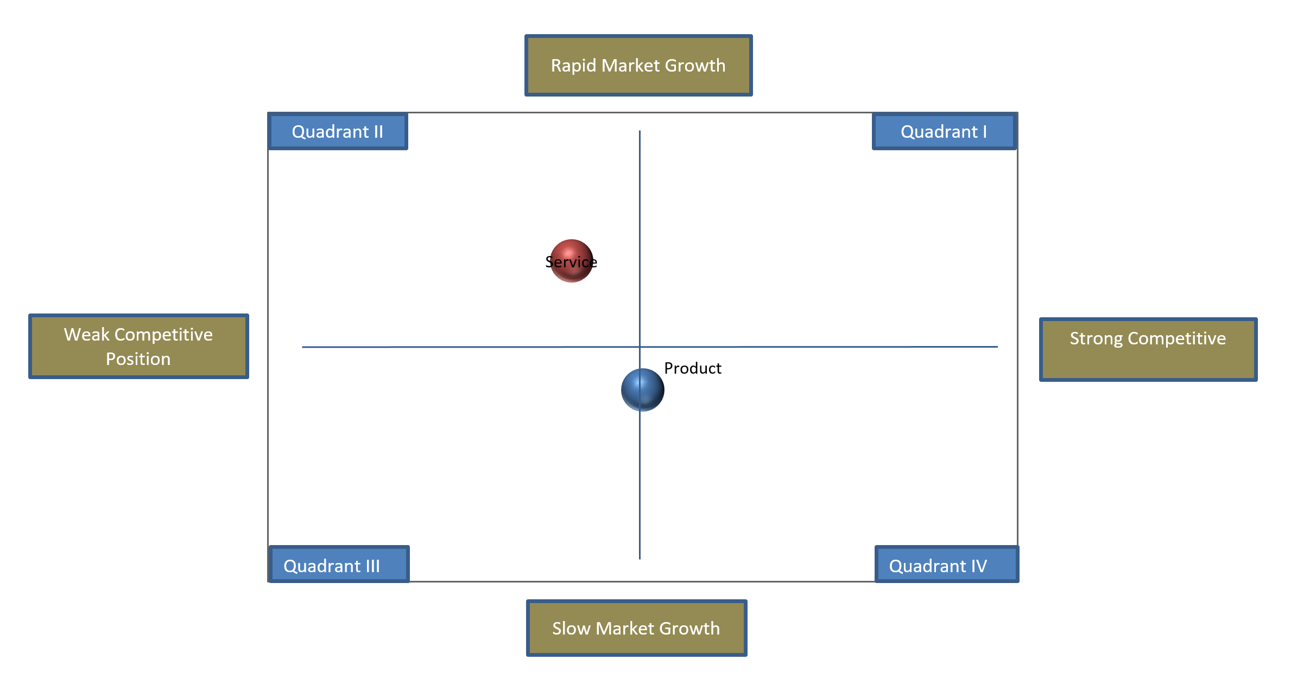

Juniper Networks Product Division represents the primary industry of the firm, and its placement on the Grand Strategy Matrix speaks to a need for bold action. Unfortunately, Juniper Networks does not have the high cash flow levels characteristically present with a strongly positioned firm with a favorable competitive position in a growing market, meaning a new and correct strategy is paramount to their continued success.

In contrast, the Service firm is in a more favorable position of a rapidly growing market, but an evaluation of their present approach to the market is needed to increase Juniper’s competitive position. Juniper Networks must determine why they are ineffective and how they can change to improve competitiveness.

A consistent theme has appeared in all matrices and analyses of Juniper Networks relative to their markets. The Product Division is responsible for the majority of the revenue, but it represents a declining industry and Juniper Networks has thus far been unable to create a clear, distinctive product related advantage to separate itself in the market. The revenue for this division has declined for three years in a row. By contrast, the Service Division has a growing share of the revenue having increased for three years in a row. It is also in a growing industry, less dependent on manufacturers and supply chains that are either outside of the firm’s control or raise the operating costs of production. All of the analyses done have resulted in two distinct strategies for Juniper Networks that will be discussed in the section below.

Quantitative Strategic Planning Matrix (QSPM)

Two proposed strategies stood out as potentially beneficial for the long-term success of Juniper Networks:
1. A shift away from being primarily involved in the Telecommunications Industry into the Software Publishing Industry over the next 5 years.

This would be accomplished by refocusing the core of the product division away from routing and switching technologies. Those resources would be redeployed to:

- Grow the service division’s offering of the Junos OS, making it available to all vendors instead of a proprietary offering only available on Juniper’s hardware.
- Focus on the Cloud product line across all customer verticals and divisions.
- Development and domination of the Product Division’s security technologies to be embedded into all offerings.

2. A focus on Cloud solutions and technologies, divesting from other portions of the portfolio to fund and power this effort.

This strategy would move away from routing technologies in the product division which have shown a steady decline for the firm and focus on growing industrial trends. Those resources would be redeployed to:

- Focus on the Switching and Cloud product lines across all customer verticals and divisions.
- Development and domination of the Product Division’s security technologies to be embedded into all offerings.

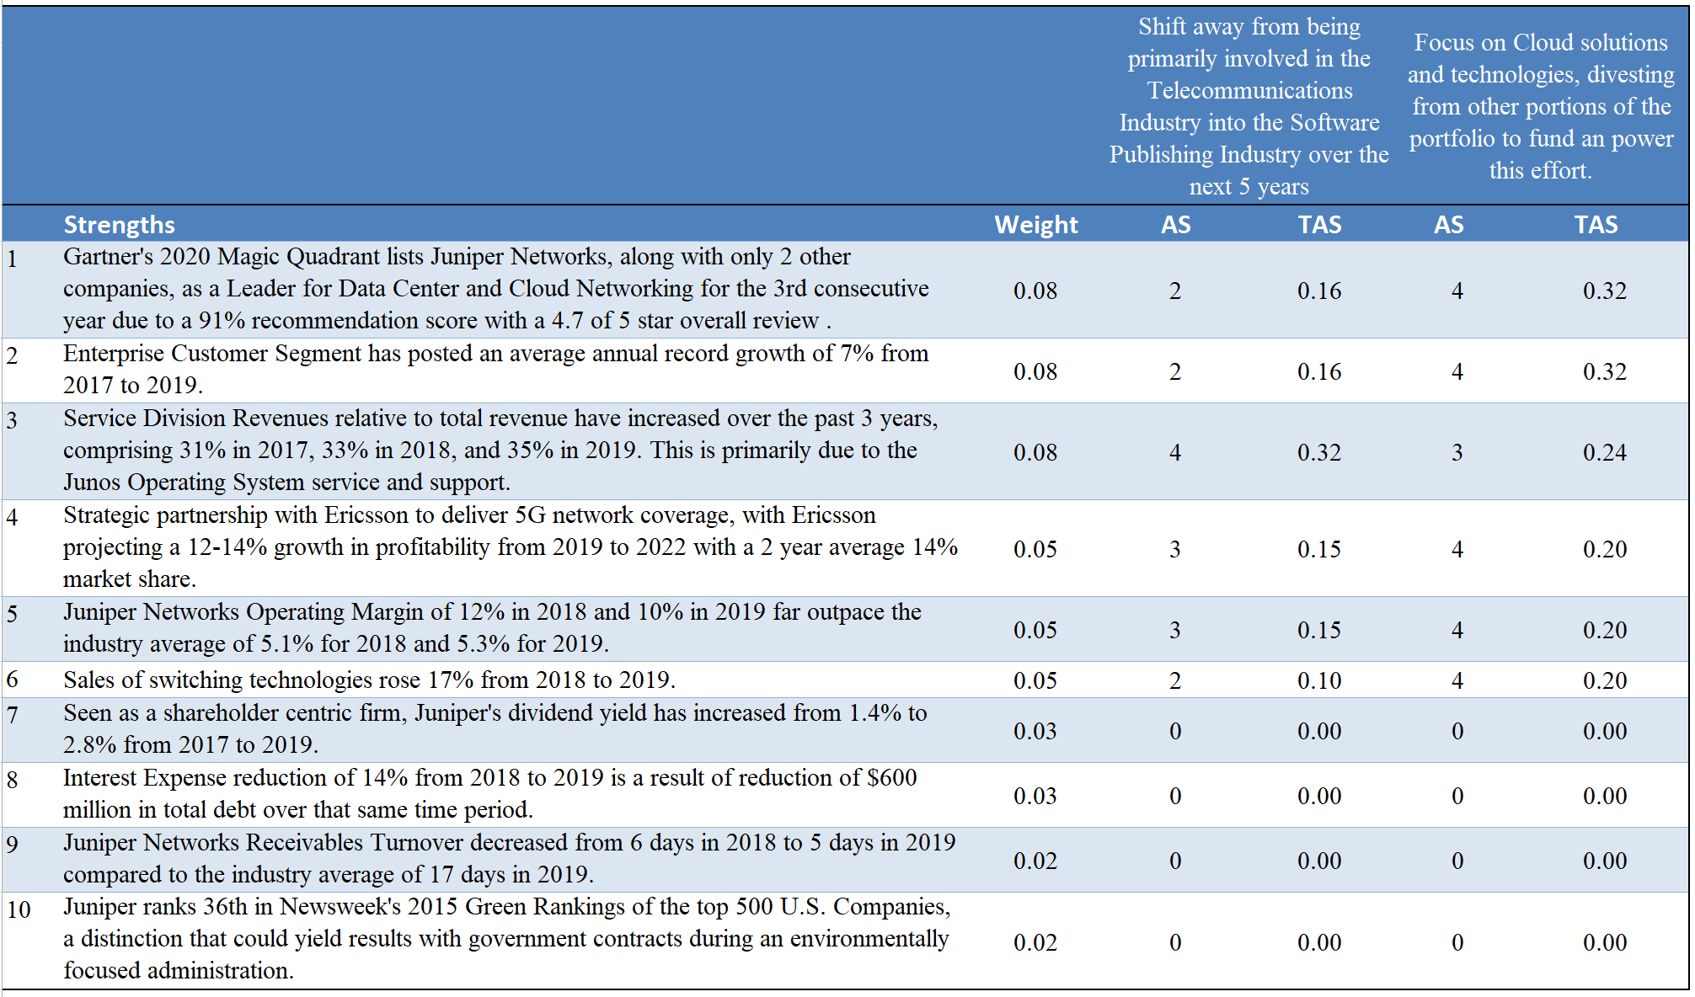

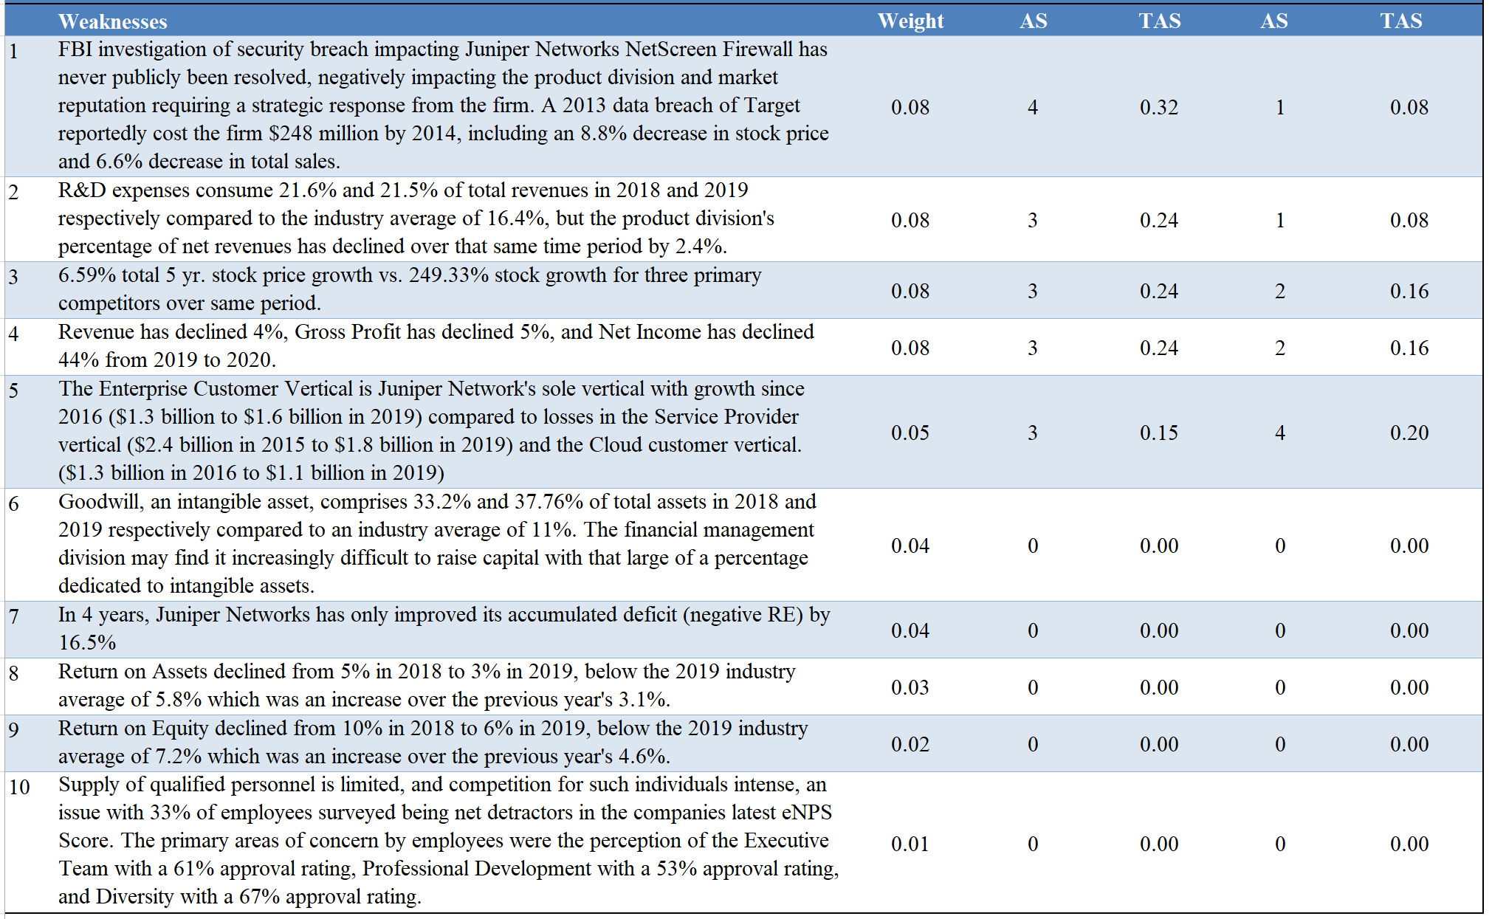

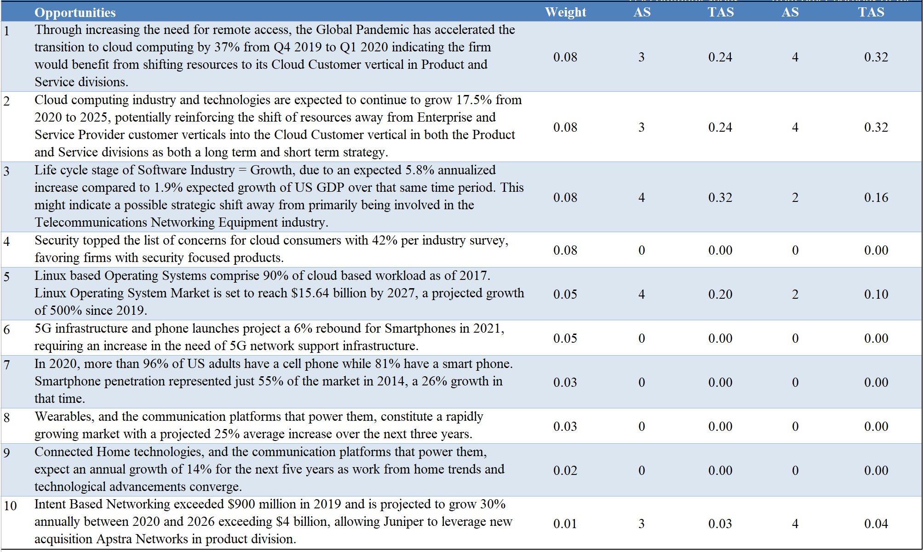

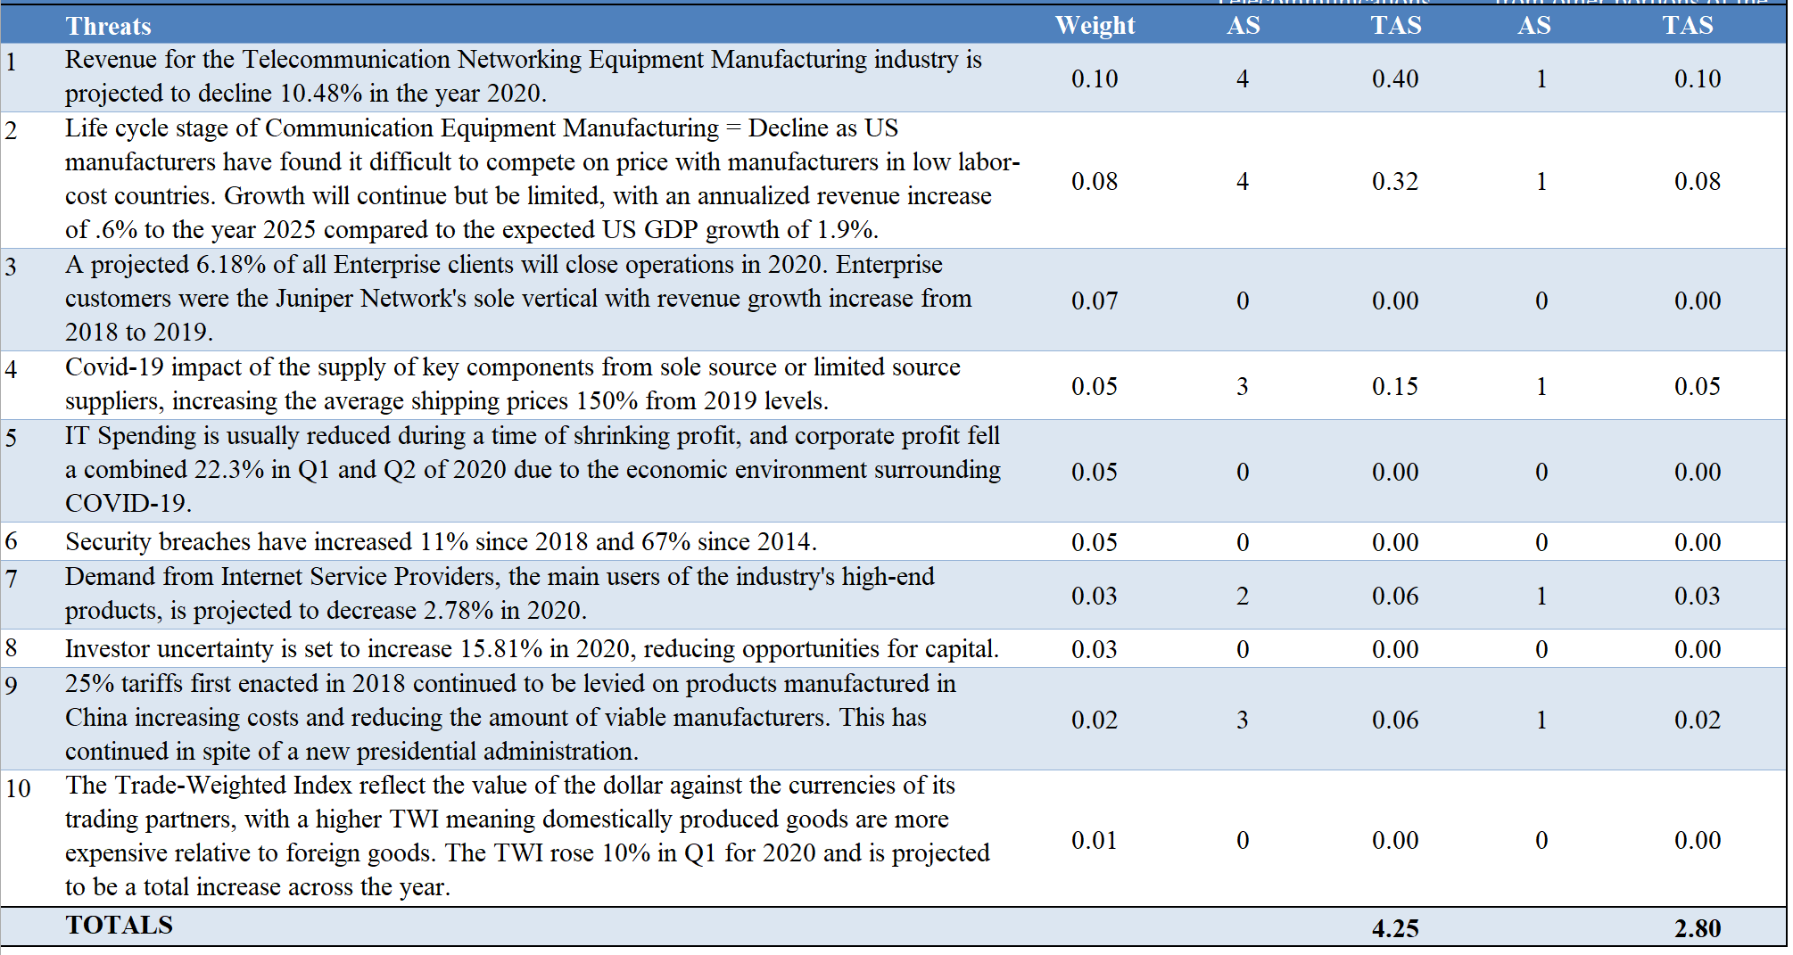

Long-term success is best found in the decision to shift Juniper Networks primarily into the Software Publishing Industry with a composite score of 4.25. The shift to Software Publishing, with a focus on licensing and servicing the Junos OS on other platforms with a focus on Cloud and 5g technologies, wearables, and connected homes would place the firm in a strategic position to capitalize on long-term industry trends and growth while removing it from long-term risks and declines. An alternative strategy would involve a narrowed focus on specific products and services, particularly Cloud solutions, with a composite score of 2.80.
Juniper Networks is in a desirable position to perform this transition by properly employing a series of strategic initiatives that will be discussed in detail in the Recommendations section to follow.

Recommendations

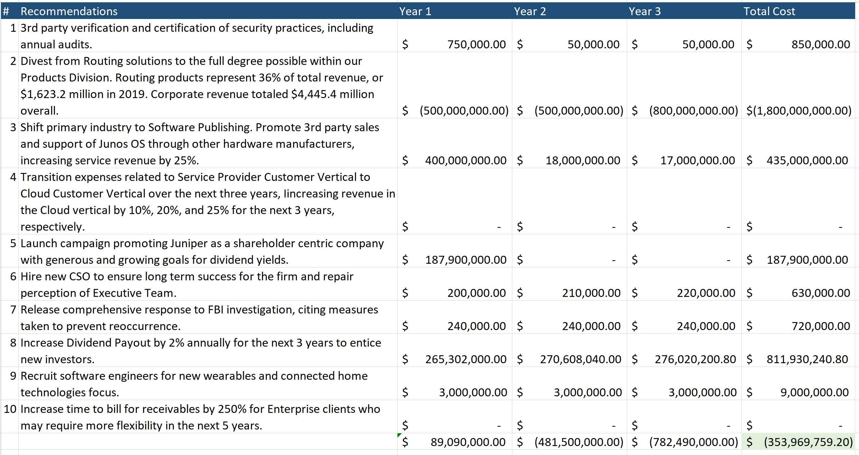

Explanations for Recommendations

- Estimation for an initial certification provided from FedRAMP (Federal Risk and Authorization Management Program) certification costs. For Juniper Networks, this is the desired accreditation to pursue. Verification costs range between $250,000 and $750,000 depending on the compliance deficiencies encountered. An allocated $750,000 is used to yield a conservative cost structure. Subsequent allotments gathered from the cost of similar 3rd party verification programs such as PCI-1 or SOC-2 Compliance.
- Revenue for routing related products decreased 25.5%, or $566.3 million from 2017 to 2019. With the U.S. telecommunications industry in decline, divesting from this product line to reinvest in the more profitable sections. Routing products represent 36% of total revenue, or $1,623.2 million in 2019. Corporate revenue totaled $4,445.4 million overall. Following the pattern of a former divestiture of the firm from a product in 2014, a planned three year transaction will be pursued with $500 million due in the years 1 and 2, with the remainder $800 million due for year 3.
- Rebranding a company is projected to cost 10-20% of a company’s marketing budget, on average. As this would be a shift to a new industry, a 20% cost, or $435 million of total operating expenses (totaling $2,174.6 million in 2019) will be allocated for this purpose assuming that all departments will require resources to make this change. The majority of this will be allocated for the first year with residual money budgeted for the two years following.
- Service Provider revenue suffered a 12% decline from 2018 to 2019 for the firm. Industry projections include a downturn in demand from Service Providers for the next 5 years. This customer vertical currently comprises 41.1% of net revenues, or $1,827.8 million in 2019. This means that it cannot be simply abandoned but must be strategically transitioned and focused to meet specific needs in the Service Provider Market. Operating expenses dedicated to this vertical are estimated at the amount of revenue applied to the Total Operating Expenses, or $891.5 million in 2019. Expenses dedicated to this vertical would be redirected to fund Cloud development efforts over time. Expected transition of Service Provider related Operating Expenses result in 10%, 15%, and 20% for the next three years, respectively. Those resources are expected to yield growth of the Cloud vertical of 10%, 20%, and 25% in the next three years, respectively.
For Service Providers that need more than Juniper Networks offerings will provide, Finding a strategic partner who can deliver quality products for this vertical and receiving a referral fee would result in offsetting revenue to the decline.
- Sales and Marketing Operating Expenses totaled $939.3 million in 2019. Using estimates of marketing rebranding, 20% of the total marketing budget should be allocated to launch such a campaign, totaling $187.9 million.
- A CSO, or Chief Strategy Officer, would be an additional member of the executive leadership team, and would serve two primary purposes. The first is to strategically facilitate the transition from a primary telecommunications firm to a primary software publishing firm. The second would be to ensure an overall strategic approach to success the firm is lacking today. Cost is based on the estimated salary of this position in California.
- Public Relations Firms can cost up to $20,000 per month through retainer fees. This budget would assume that the firm would contract the best PR firm available on retainer for three years. (12 months x 20,000, per year)
- Payment of Dividends for 2019 totaled $260.1 million. Estimates for this recommendation were reached by increasing that amount and subsequent years by 2% annually.
- Average salary for software engineers in California is $123,000 annually. This is an assumed team of 20 people, with a 25% assumption per person of benefits. ((123,000 x 20) x 1.025)
- By extending the time to bill to the industry average, Juniper Networks would make its product more desirable to Enterprise clients who may be facing a downturn in revenue due to COVID-19 impacts. Juniper Networks had a Days of Receivables that was one-third of the industry average. Extending this would let the billing cycle for Juniper Networks match the industry average and avoid a competitive disadvantage.

Organizational Chart

Below is the current organizational chart for Juniper Networks:
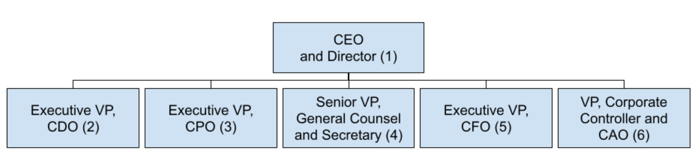

The individuals in the organizational chart are as follows:

- Rami Rahim - Chief Executive Officer and Director
- Anand Atherya - Executive Vice President and Chief Development Officer
- Manoj Leelanivas - Executive Vice President and Chief Product Officer
- Brian Martin - Senior Vice President, General Counsel and Secretary
- Kenneth Miller - Executive Vice President and Chief Financial Officer
- Thomas Austin - Vice President, Corporate Controller and Chief Accounting Officer

It is helpful to recall that one of the weaknesses for Juniper Networks was the internal rating of its leadership team. This stems in part from a structure that promotes ambiguity in separating product strategy, under the control of the Chief Product Officer (CPO) from engineering strategy, under the control of the Chief Development Officer (CDO). Juniper Networks lacks a Chief Operating Officer to centralize these strategies in an integrative approach.

This organizational chart suffers from dual, and in some cases, triple titles for executives. Juniper Networks should seek to clarify the roles associated with the executives by having clear titles that convey the scope of that executive’s responsibility.
Yet another critique of this group would also recognize a lack of gender diversity with none of the chief officers being female. In considering a reorganization of the leadership team, this should be addressed.

Proposed Organizational Chart

The following chart is proposed to facilitate the transitions listed in the recommendations as well as continued success.

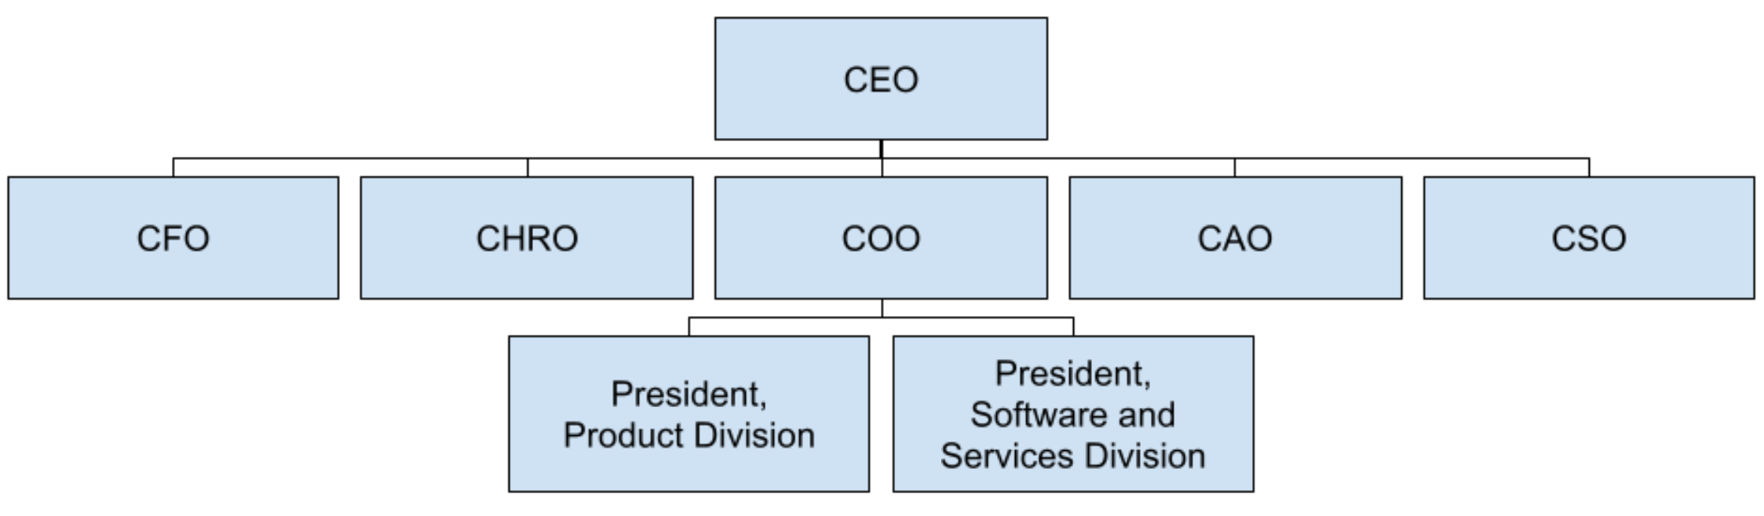

The transition from a primary focus on the Telecommunications Manufacturing Industry into a primary focus on the Software Publishing Industry will take a concerted approach among all product teams. To facilitate this, the heads of the Engineering and Product Teams have been moved underneath a Chief Operating Officer. The titles Chief Product Officer and Chief Development Officer have also been retitled as Presidents of the two clarified divisions of the company. An excellent candidate for the COO role is Anna Johnston, a Principal Engineer for Juniper Networks and Adjunct Professor of Cryptography at Johns Hopkins University. This will ensure that both divisional presidents report to a well credentialed, security minded individual, while also bringing gender diversity to the executive leadership team.

Furthermore, there should be a continued effort of strategic alignment between all branches of the company based on strategic planning and market understanding. The Chief Strategy Officer will fulfill that role, presenting pertinent information to the Executive Leadership Team and ensuring each part of the company is delivering on the chosen strategy. It is highly recommended that highly qualified female candidates be considered for this role as well, further introducing gender diversity into Juniper Network’s Leadership Team.

In addition to the above changes, the General Counsel and Secretary has been serving as an interim CHRO (Chief Human Resources Officer) for more than two years. Given his job description as listed in the financial statements, this is a fitting title and interim positions should not last for several years. Other positions were clarified and dual titles removed. The proposed C-level executives are as follows:
Chief Executive Officer (CEO)
Chief Financial Officer (CFO)
Chief Human Resources Officer (CHRO)
Chief Operating Officer (COO)
Chief Accounting Officer (CAO)
Chief Strategy Officer (CSO)

Perceptual Map

The following perceptual map is based on an analysis of a firm’s flexibility to respond to industry changes and product revenue growth.

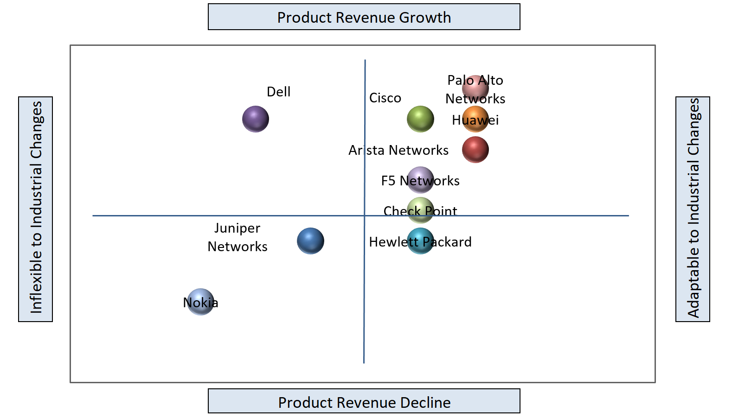

The ability to respond to technological changes is a critical component of the Telecommunications Manufacturing Industry. At this time, Juniper simply does not have the resources to respond to these changes in a timely manner compared to other firms in the market. Furthermore, when reviewing product revenue growth, Juniper Networks has one of the lowest positions in the competitive market for the last three years. This perceptual map continues to illustrate that Juniper Networks’ next strategic plan is critical to its long-term success. It cannot continue to remain in this competitive position with positive expectations.

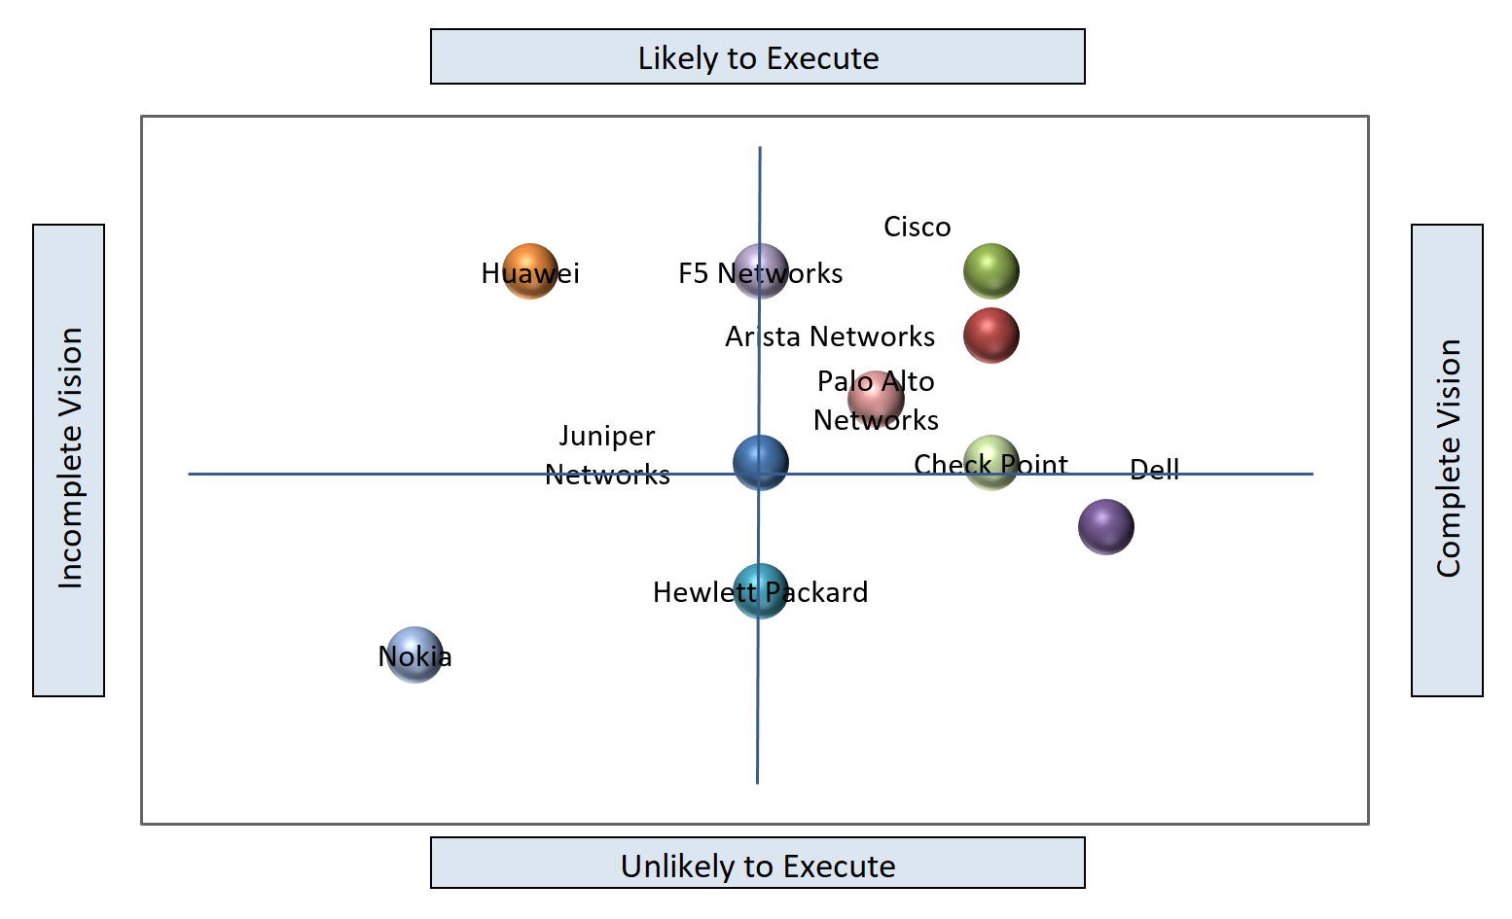

A second perceptual map illustrates the same companies in the industry on a different set of axes. Each company has cast a vision in the public marketplace that it wishes to achieve. Independent firms that judge and rate such companies have stated where these companies fall on the completion of that vision, and how likely they are to execute that vision given the strengths and weaknesses of the companies themselves. A company with fewer resources and poor management would be less likely to execute on the stated vision of the company. Juniper Networks remains firmly entrenched as a question mark in the minds of the industry as can be seen by the positioning in the middle of the matrix. While it is possible Juniper Networks can accomplish its stated goals, it is just as likely that they could fail to achieve those goals.

Firm Valuation

The closest competitor to Juniper Networks is Arista Networks. Many other competitors are much larger corporations with varied business units, but Arista’s portfolio closely resembles that of Juniper Networks and the two firms have also been listed as leaders in the industry by independent rating companies.
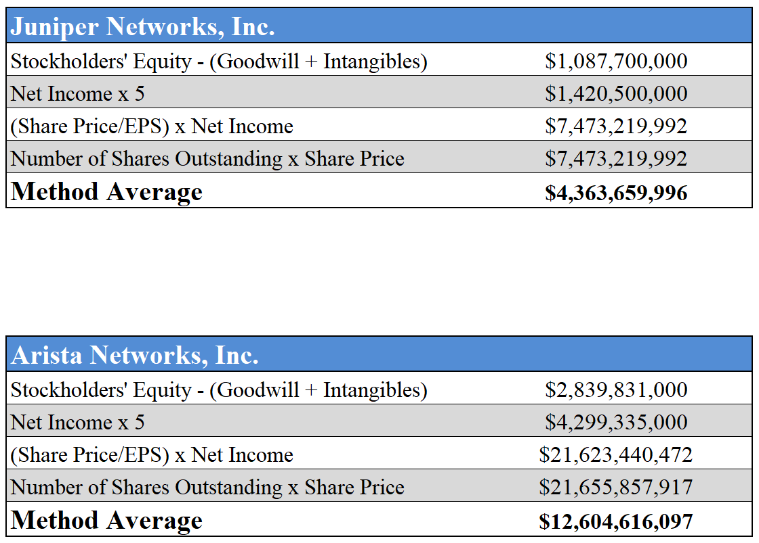

The true difference in the evaluations begins to take place with the metrics involving the share price. Juniper Networks stock price of $22.61 per share is less than one-tenth of Arista Networks $283.16 per share. Juniper Networks needs to take a strategic approach to raising its share price. Recommendations 5 and 8 listed above directly deal with this need to raise the valuation of the firm.

EPS-EBIT Analysis

The strategy for Juniper Networks relies on reducing the firm’s product diversification. This includes divesting the routing products and using those funds to grow the Software and Services division. No additional capital will be needed, given current projections, resulting in no difference between the choices of equity and debt financing.

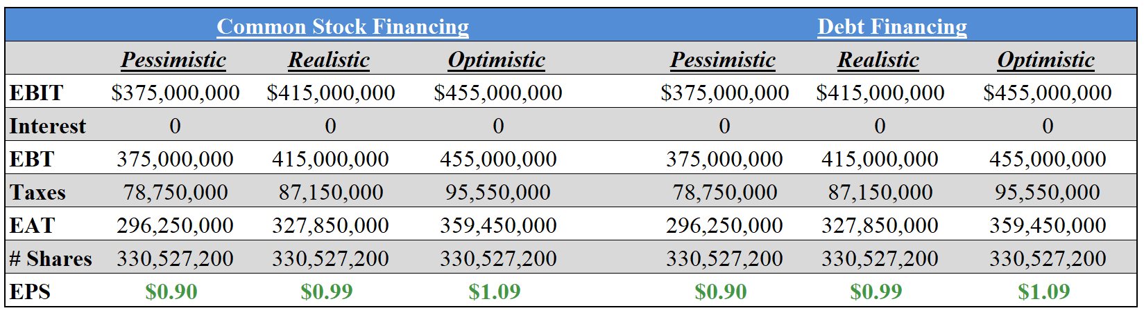

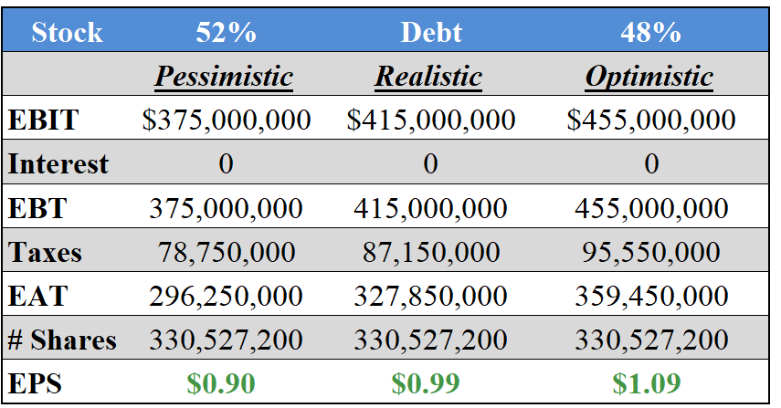

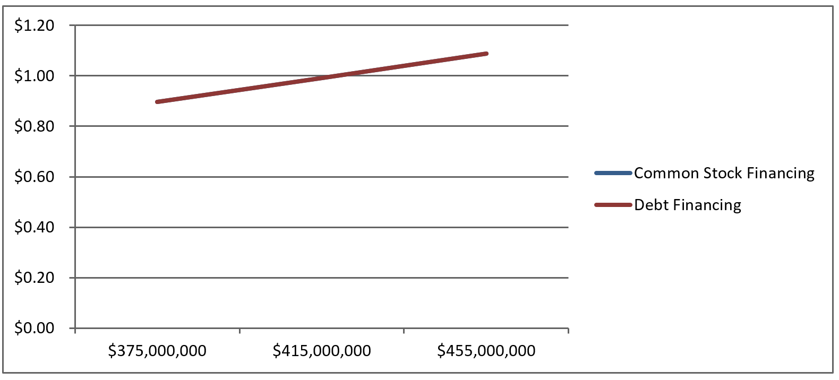
Furthermore, the strategy of the firm also includes increasing the price of the stock through an aggressive marketing campaign. Equity Financing would align with that goal much better than Debt Financing. Juniper Networks is in a place where it could use debt leverage to grow, but the preference with the current strategy would be to grow equity through releasing treasury stock into the market at a premium from the purchase price. This makes Equity Financing the best choice for funding the future endeavors of the firm.

As noted previously, the recommendations include divesting from the routing products to fund the transition from Telecommunications Manufacturing to Software Publishing and Service. Should the board not approve the divestment yet desire to pursue the industry change and implement the other recommendations the cost of all other recommendations would be $1.45 billion. As it is possible that an alternative strategy could be requested, that figure was used with the EPS/EBIT analysis with the following results:

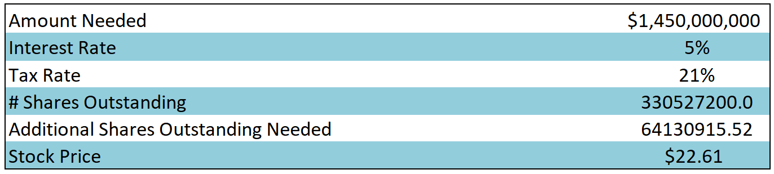
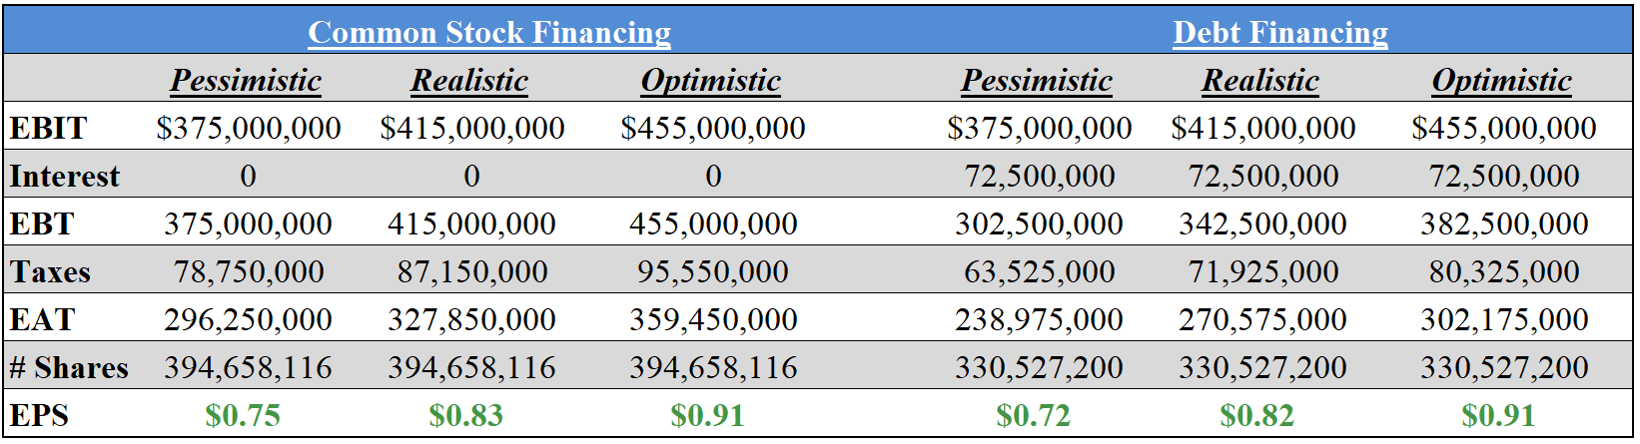
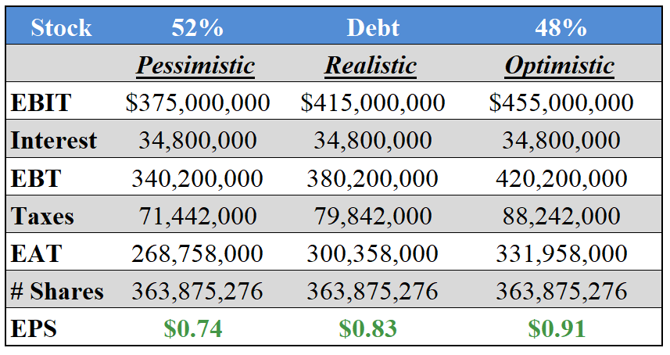
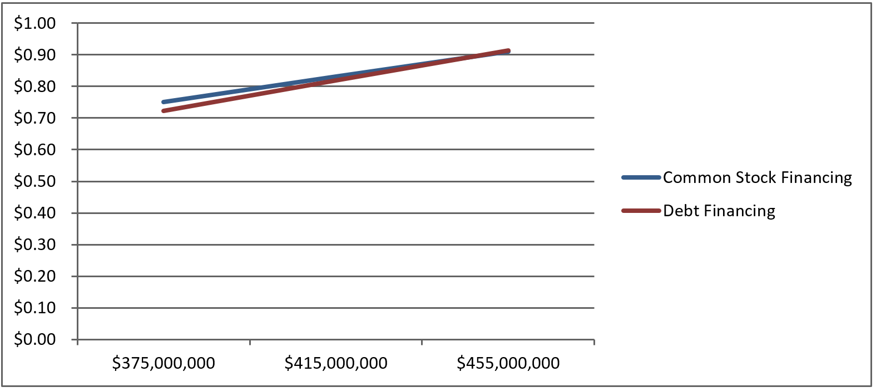

Equity Financing remains the preferable option under this scenario as well, with improved Earnings Per Share for years one and two. Debt financing would become as preferable as Equity in year three, given no other changes. This would suggest that the firm is at an appropriate level of debt leverage and would be better suited to explore Equity Financing through Common Stock. As this strategically aligns with other goals and projected outcomes, Equity Financing is the clear choice for Juniper Networks at this time.

Projected Financial Statements

Should the firm follow the given recommendations it will be divesting itself of a product associated with a shrinking industry to more fully invest in products related to a growing industry. This will also capitalize on the strengths of the firm while minimizing the weaknesses. The below tables represent the projected results of these recommendations:

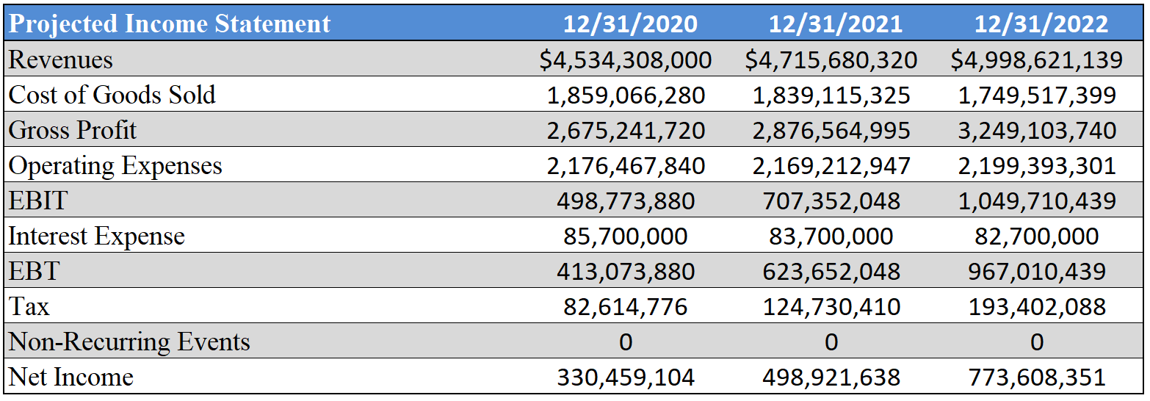

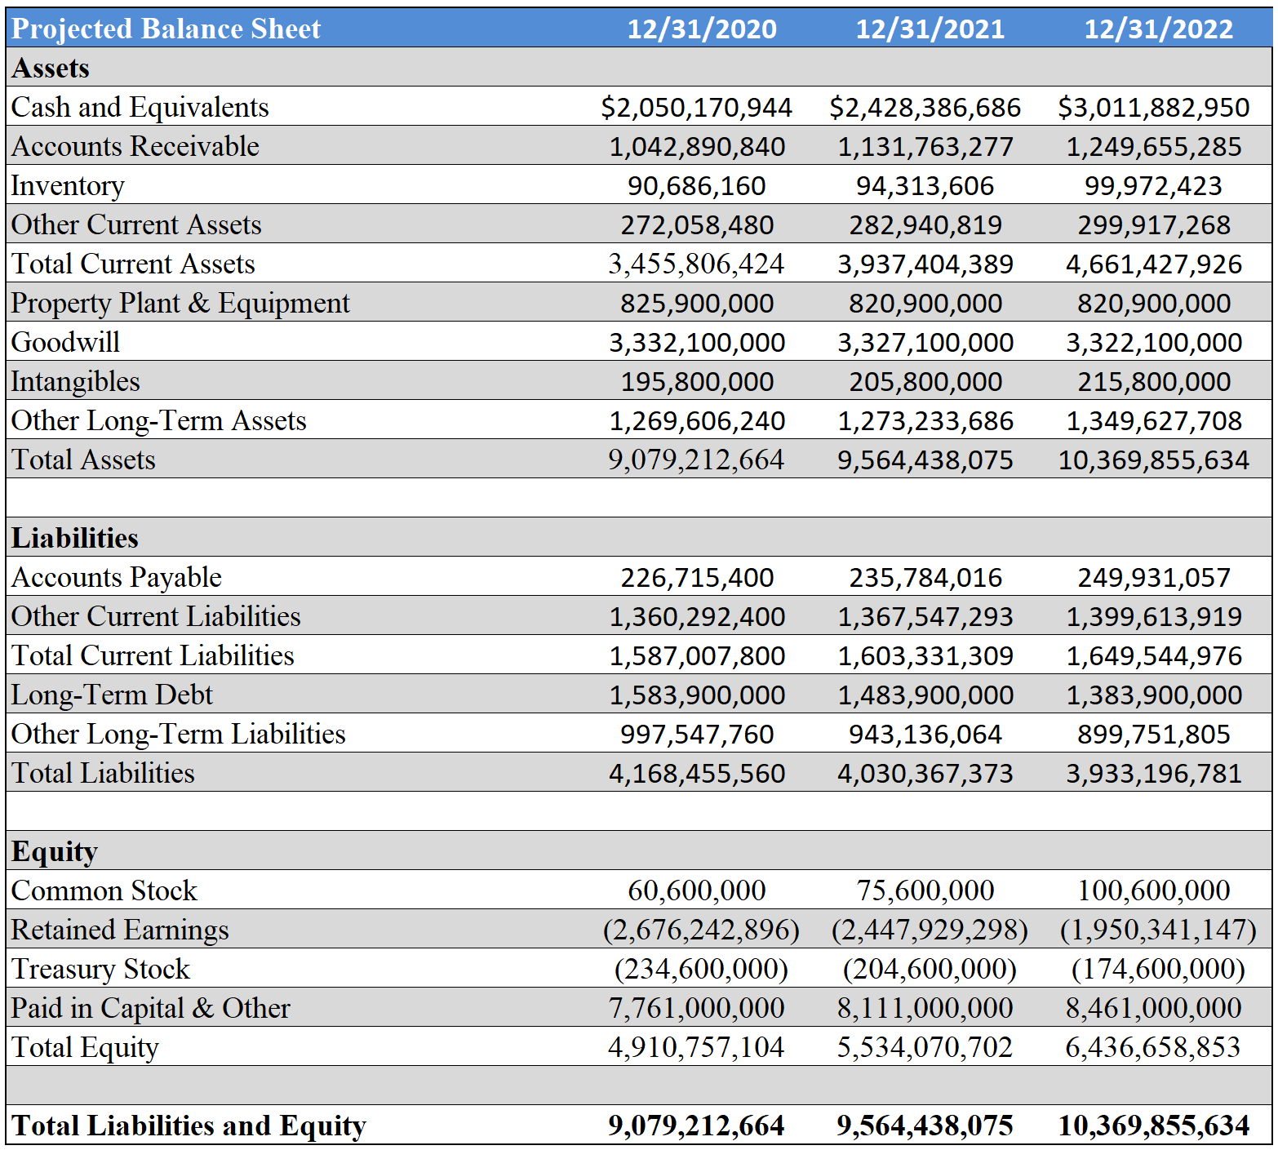

Treasury Stock will continue to decline as the shares are released to sell at premium. The Retained Earnings (Accumulated Deficit) balance will continue to improve due to the increased revenue stream.

Projected Financial Ratios

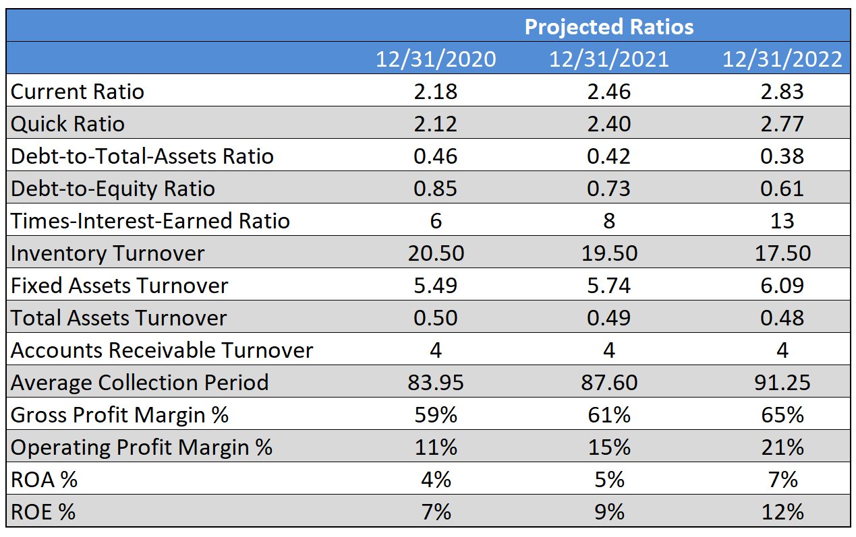

Among the weaknesses listed for Juniper Networks was the ROA and ROE % ratios. These were well below the industry average for the firm in the historical ratios, and had trended to severe declines in recent years. These have now risen to match the industry leaders for these ratios. As planned, the Average Collection Period did rise as the firm promotes a longer pay cycle for Enterprise clients as a strategic advantage.

Retained Earnings Table

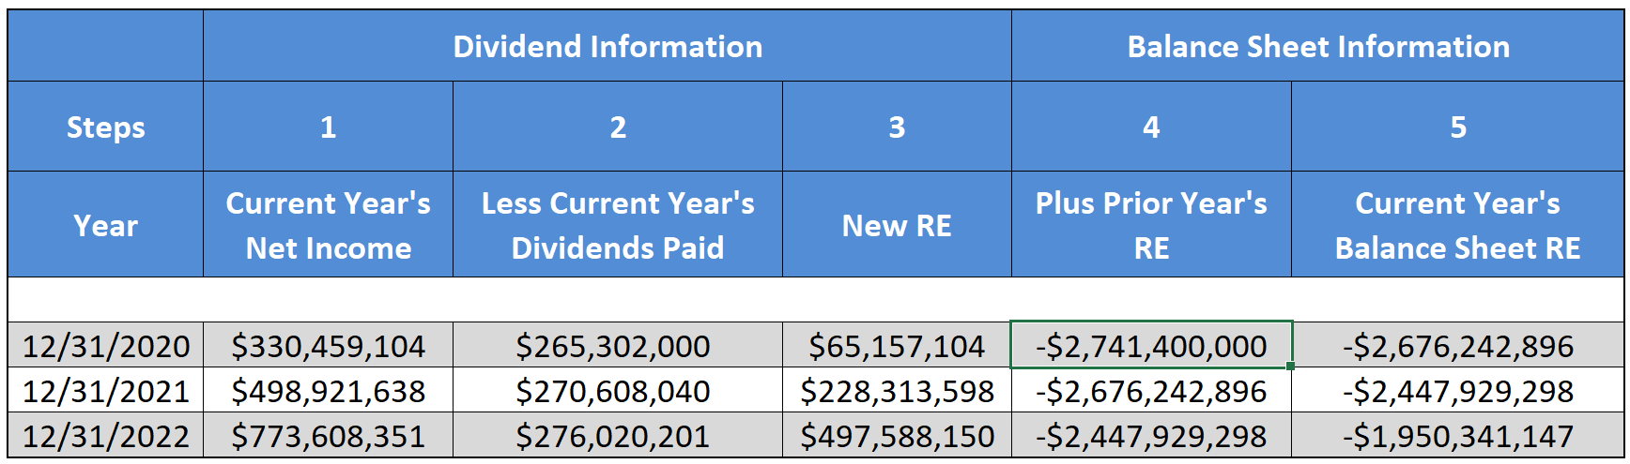

A significant weakness of Juniper Networks is the size of its Accumulated Deficit (Negative Retained Earnings). The recommendations given, as planned, have increased dividend payouts while simultaneously reducing the accumulated deficit. These figures are exactly what the firm needs to see to experience long-term growth and success. The increased dividends, plus a stronger financial position of the firm, should cause the stock price to rise and the valuation of the firm to approach that of its closest competitors.

Epilogue

The recommendations given in this report can be broken down into a two-pronged strategy for Juniper Networks:
1. Simplify organizational structure and product offerings

Juniper Networks needs to simplify its organizational structure and product offerings. While Juniper Networks is known for making quality products it struggles to capture market share necessary to achieve sustainable growth. It has a diverse portfolio of options, but this diversification has not yielded the expected return. Juniper Networks’ product portfolio currently reflects a reality of doing many things well, but nothing they produce is considered the best in class.

2. Transition primary industries

The U.S. Telecommunication Manufacturing Industry continues to decline as international firms with lower operating costs enter the market. This industry is ever-changing and fast paced. New technologies and advancements can appear quickly, and many firms have significant cash reserves on hand to either be a “fast-follower” or simply purchase new companies or patents and incorporate their technological advancements into the firm’s portfolio. The ability to adjust quickly is critical to success in this space, and Juniper Networks lacks this ability compared to its principle competitors.

Juniper Networks also produces and distributes the JUNOS Operating System, a distribution of Linux that they only provide on equipment they also manufacture. The Software Publishing Industry is growing, and numerous opportunities on the horizon for the market play to Juniper’s strengths as a service organization. The Service Division of Juniper outperforms the Service Division of many of its principal rivals relative to growth and total percentage of company revenue. There is no reason that Juniper could not offer this software distribution to any manufacturer, and build it with the engineering and skill necessary to connect devices of all kinds to one another simply through innovation as the company states it wishes to do.

These plans are complementary, and the firm has what it needs to accommodate these plans and successfully change itself into a company with promising growth. It need not completely abandon hardware production to achieve this, and in fact it cannot hope to do that and continue funding its business. A transition to another primary industry takes time and expertise, and they must begin that journey as quickly as possible to ensure success. Juniper Networks reveals itself to be a question mark through multiple analyses, squarely stuck between potential growth and potential failure with too many uncertainties for investors to trust. As long as this remains true, Juniper Networks continue to underperform in relation to investor related metrics compared to the others in this industry. These recommendations align the growth of the marketplace with Juniper’s strengths to give the best opportunities for success. With its solid foundation to build on, Juniper Networks can become the leader of software solutions that power the future.

